Prompt:
How did Christianity change from a persecuted sect of followers to the official religion of the Roman Empire?

Vocabulary:
Persecuted- hostility and ill-treatment, due to race, political, or religious beliefs
Sect-a group of people with somewhat different religious beliefs

Directions: Use the following primary and secondary sources to answer the prompt above.We will go through the first couple documents together, but it will be up to you and your table groups to finish the rest. Make sure you pull out any vocabulary that you do not know and define those terms because they may help with understanding of the document. After you read each document you will need to summarize the document and explain how it will help you answer the prompt.

Use SKIMS for each of the documents.

S- Skim or Clean Read
K- Key Terms (Highlight)
I- Identify Intent of the Author (Why was this written? Who wrote it?)
M- Underline Main Ideas in the document
S- Summarize document including answering the question (How does this document help me answer the Prompt?)

Document A:

In the first century CE, Paul was an important missionary for the Christian Church,
traveling through the Roman-controlled Middle East, Turkey Greece and Italy. “Over 30
years, Paul clocked up around 10,000 miles, traveling across the Roman Empire. He
preached in some of the empire’s most important cities. Although places like Ephesus,
Philippi, Corinth and Athens looked magnificent, they were also home to tens of
thousands of poor, desperate people who were the perfect audience for the Christian
message of eternal life.

Source: Christian New Testament of Bible- Acts, Chapter 16 (Paul's arrest in Phillipi, a city in the Roman Empire) 49 CE

But when her masters saw that the hope of their gain was gone, they seized Paul and
Silas, and dragged them into the marketplace before the rulers. When they had brought
them to the magistrates, they said, “These men, being Jews, are agitating our city, and
advocate customs which it is not lawful for us to accept or to observe, being Romans.”
The multitude rose up together against them, and the magistrates tore their clothes off of
them, and commanded them to be beaten with rods. When they had laid many stripes on
them, they threw them into prison, charging the jailor to keep them safely, who, having
received such a command, threw them into the inner prison, and secured their feet in the
stocks.

Identify Intent: (Why did the author write this? Who was the audience? What bias might the author have?)
- The intent of the author was to show the brutality of the Roman officials when confronted with people that advocate customs and ideas that go against traditional Roman ones. The Audience was most likely people that Paul was targeting to convert to Christianity and/or people that had previously been oppressed or treated poorly by the Romans.

Vocabulary
magistrate- a civil officer of the law
multitude- a larger number of group
Summary of Document (What does it mean? How would it help you answer the prompt?):

Document B:
On July 16, 64 ce, the “Great Fire” destroyed large sections of the city of Rome. In the
days after the fire, rumors that the emperor Nero had started the fire spread. The
historian Tacitus wrote the entry below.

Source: Tacitus, Annales, (64 ce)

And so, to get rid of this rumor Nero set up as culprits and punished with the utmost
cruelty a class hated for their abominations, who are commonly called Christians.
Christus… Thus those who confessed (i.e.. to being Christians) were first arrested, then
on evidence from them a large multitude was convicted, not so much for the charge of
arson as for their hatred of the human race. Besides being put to death they were made
objects of amusement; they were clothed in hides of beasts and torn to death by dogs;
others were crucified, others were set on fire to illuminate the night after sunset.

Identify Intent: (Why did the author write this? Who was the audience? What bias might the author have?)

Vocabulary:
culprit-
crucified-

Summary of Document (What does it mean? How would it help you answer the prompt?):

Document C:

Eusubius was a Roman historian who would become a Christian bishop in 314 ce.

Source: Eusubius, (303 ce)

This was the nineteenth year of the reign of Diocletian in Dystrus (which the Romans call
March), … and royal edicts were published everywhere, commanding that the churches
should be razed to the ground, the Scriptures destroyed by fire… if they persisted in the
Christian profession, be deprived of their liberty. And such was the first decree against
us. But issuing other decrees not long after, the Emperor commanded that all the rulers of
the churches in every place should be first put in prison and afterwards compelled by
every device to offer sacrifice [to the Roman gods}.

Identify Intent: (Why did the author write this? Who was the audience? What bias might the author have?)

Vocabulary:
edicts-
razed-

Summary of Document (What does it mean? How would it help you answer the prompt?):

Document D:

Source: Marcus J Borg and John Crossan, The First Paul

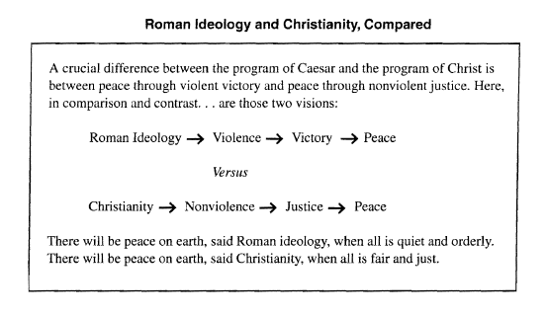
Identify Intent: (Why did the author write this? Who was the audience? What bias might the author have?)

Vocabulary:

Summary of Document (What does it mean? How would it help you answer the prompt?):

Document E :

Roman society did believe in immortality, but it was a bit complicated. The ancient Romans believed that when one died, one was met by Mercury, the messenger god and son of Jupiter, and taken to the river Styx, where they were received and then judged. After judgment, if they passed muster, they would be sent to one of the two afterworlds, one for heroes, one for commoners.

Source: Religious historian Helmut Koester, quoted PBS documentary From Jesus to Christ

Why was the Christian community something that people wanted to join? ... One [reason] was certainly that the message that was preached here promised ... immortality. a future life which would be liberation from sickness and from disease and from poverty, and individual isolation. There is a future for the individual ... beyond the powers of this world ....

Identify Intent: (Why did the author write this? Who was the audience? What bias might the author have?)

Vocabulary:

Summary of Document (What does it mean? How would it help you answer the prompt?):

Document F:

Source: Religious historian Helmut Koester, quoted PBS documentary From Jesus to Christ

[We ask again], why was the Christian community something that people wanted to join? '" Rome is a very strict hierarchical system, in which the emperor is at the pinnacle, all the way up and then all the blessings in the world that come to people come down from above. The emperor is the conduit [connecting path] to the divine world. And if you're at the bottom of that social pyramid, not a whole lot of things are coming down to you anymore ....

Now the Christian community, as we have it particularly in the letters of Paul, ... says in Christ there is neither Jew nor Greek, neither male nor female, neither slave nor free .... Here is a community that invites you, which makes you an equal with all other members of that community. Which does not give you any disadvantages. On the contrary, it gives even the lowliest slave personal dignity and status. Moreover ... the care for each other becomes very important. ... If they are hungry, they know where to go. If they are sick, there is an elder who will lay on hands to them to heal them.

Identify Intent: (Why did the author write this? Who was the audience? What bias might the author have?)

Vocabulary:

Summary of Document (What does it mean? How would it help you answer the prompt?):

Document G:

Pliny the Younger was a respected Roman administrator who, in 103 CE, was sent to Bithynia (modern western Turkey) by the emperor to help govern this troubled area. Part of the unrest was caused by a new group that called themselves Christians, who refused to buy sacrificial items to offer the Roman gods. Pliny served as judge at the trials of many of those accused of disrespecting Roman beliefs. His reference to them as "Christians" is early evidence that Christianity had become a distinct religion in the Roman Empire.

Source: Letter written by Pliny the Younger, a Roman Judge, 112 CE

(H)ere is the procedure I have followed in the case of those brought before me on account of being Christians. I asked them whether they were Christians. If they confess to it, then I ask them a second and third time, while threatening punishment. Ifthey persist, larder them to be led away [to execution]. For whether there be anything at all they should admit to [in the way of a crime], I have no doubt that at least stubbornness and inflexible obstinacy ought to be punished.

Identify Intent: (Why did the author write this? Who was the audience? What bias might the author have?)

Vocabulary:

Summary of Document (What does it mean? How would it help you answer the prompt?):

Document H :

Paul was a Jewish tent-maker from the city of Tarsus in modern-day Turkey. Probably a few years younger than Jesus, Paul never met the preacher. In fact, he was angry about Jesus’s claims and he spent several years criticizing those who believed. Then, according to Paul’s own account, he saw the resurrected Jesus while traveling on the road to the city of Damascus, and it changed his life. He spent the next 30 years traveling the eastern Mediterranean world, spreading Jesus’s teachings. It is believed that he wrote most of the 13 New Testament letters on his journeys in the 50’s CE.

Source: Missions of Saint Paul- Oxford Illustrated History of Christianity

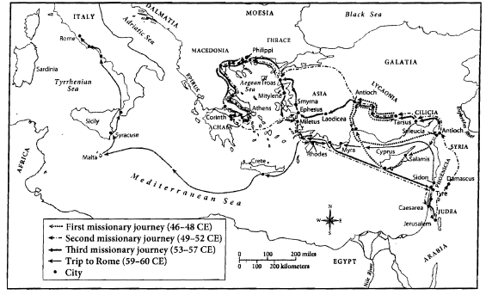

Summary of Document (What does it mean? How would it help you answer the prompt?):

Document I:

Constantine was the emperor of the Roman Empire from 306-337 ce. Though his mother
was a Christian, Constantine did not become a Christian until he was 42 years old in the
year 312 ce, after winning an important battle with his troops.

Source: Emperor Constantine, The "Edict of Milan " (313 ce)

Therefore, your Worship should know that … concerning the Christians and now any one
of these who wishes to observe Christian religion may do so freely and openly, without
molestation. We thought it fit to commend these things most fully to your care that you
may know that we have given to those Christians free and unrestricted opportunity of
religious worship. When you see that this has been granted to them by us, your Worship
will know that we have also conceded to other religions the right of open and free
observance of their worship for the sake of the peace of our times, that each one may
have the free opportunity to worship as he pleases; this regulation is made we that we
may not seem to detract from any dignity or any religion.

Identify Intent: (Why did the author write this? Who was the audience? What bias might the author have?)

Vocabulary:

Summary of Document (What does it mean? How would it help you answer the prompt?):

Document J:

Theodosius I was the emperor of Rome between 379 and 395 ce. He made Christianity
the state religion of the Roman Empire in 380 ce.

Source: Emperor Theodosius, Theodosian Code (380 ce)
It is our desire that all the various nations which are subject to our clemency and
moderation, should continue to the profession of that religion which was delivered to the
Romans by the divine Apostle Peter… let us believe in the one deity of the father, Son
and Holy Spirit, in equal majesty and in a holy Trinity. We authorize the followers of this
law to assume the title Catholic Christians… the others, since in our judgment they are
foolish madmen, we decree that they shall be branded… heretics.

Identify Intent: (Why did the author write this? Who was the audience? What bias might the author have?)

Vocabulary:
clemency- a merciful or kind act.
moderation- Mild or calm behavior.
apostle- a missionary of the early Christian Church.
deity- a god
heretic- a person who publicly disagrees with official teachings of the

Summary of Document (What does it mean? How would it help you answer the prompt?):

