World History Name:
Mr. Murray Date:
Introduction to the Crusades Block:

Between the 11th and 13th centuries (1095-1272), Europe and the Middle East were divided up into two dramatically different worlds, one Christian and one Muslim. Whereas Western Europe was Roman Catholic, the Middle East was Muslim; whereas Western Europe was made up of constantly fighting feudal kingdoms, the Middle East was unified under the Islamic Empire; whereas Western Europe was backward, illiterate and superstitious, the Muslim world was the most advanced civilization of its time; whereas Western Europe was barely crawling out of the Dark Ages, the Islamic Empire was the center of learning and revolutionary thinking; whereas Western Europe was trying to remember the technological advances of the Roman Empire, Islam was discovering algebra, wearing expensive silks, and experimenting with the use of spices to preserve food; whereas Western Europe was dark and backwards, this same period of time was the “Golden Age of Islam.”
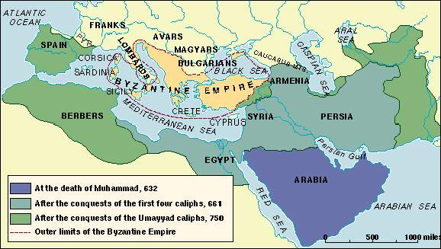
Jerusalem is a special city for three religions—Judaism, Christianity, and Islam. For Jews, it was the city where King David ruled and where the great Temple had stood. For Christians, it was the city where Jesus had lived, preached, and been crucified. For followers of Islam (Muslims) it was where their leader, Mohammed, ascended to heaven to meet with Allah. Jerusalem was full of people from all three religions who lived there is peace for over three hundred years. Pilgrims are individuals who take a trip to a religious site. Taking a trip to a religious city is called a pilgrimage. For example, while Jerusalem was the most popular city for Christian pilgrims, Muslim pilgrims also journeyed to Mecca. Christian pilgrims by the tens of thousands came from Europe to visit the Holy Land and “to walk in the footsteps of Jesus.” The Holy Land was what Christians in the Middle Ages called the Middle East. The Holy Land today would be Lebanon, Syria, Israel, and Palestine. To be a good Christian during the Middle Ages was to visit the Holy Land and to take a pilgrimage to Jerusalem. Muhammad ordered Muslims to take a pilgrimage to the Meccas at least one time in their lives. The Muslim pilgrimage to Mecca is called the “hajj.”
During the Middle Ages (1000-1400) Christian pilgrims by the tens of thousands came from all over Europe to visit the Holy Land and to see Jerusalem. In 600 CE the Ottoman Turks conquered the Middle East and Jerusalem. The Ottoman Turks came out of modern day Turkey and were Muslim. Thus since 600 CE, the Middle East and Jerusalem were part of the Islamic Empire. The empire extended from modern day Iran, through the Middle East and all the way west to Spain. The Islamic Empire was the most advanced civilization of its time. Spices, running water, advanced irrigation techniques, hygiene, and sophisticated building design were all characteristics of Islam. In terms of literacy, technology, and medicine, and mathematics the Islamic Empire was two hundred years more advanced than Christian Europe.
In 1071 CE, the Islamic Empire closed the Holy Land and Jerusalem to pilgrims from Western Europe. Twenty-four years later, on 27 November 1095, Pope Urban II spoke to a Christian audience in Clermont, France urging his listeners to free the Holy Land from the Muslims. His words were strong and powerful:
“Jerusalem is not held captive by the enemies of Christ, those who do not know God, the heathen (non-Christians). Jerusalem wants to be free and begs you to come help! Who will take up this work, who will right these wrongs, who will recover this territory, if you won’t?”
The crowd shouted out, “God wills it! God wills it!” and Western Europe began preparing for Holy War against the Muslims. Pope Urban wanted all the kingdoms of Western Europe to come together and to free the Holy Land from the Muslim infidels. “Infidel” literally means, “one without faith.” The Catholic Church defined “infidel” as a person who did not believe that Christ was the Son of God. By this definition, all Jews and Muslims were infidels and all would burn in Hell for eternity unless they converted to Christianity.
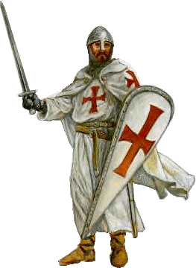
The Crusades were a series of religious wars waged by Catholic Europe against the Muslim world. The Crusades took place in the middle of the Middle Ages (the period known as the High Middle Ages). The goal of the Crusades was to regain the Holy Land from Islam. The term “Crusade” comes from the French croisé, or croix, meaning cross; “croisade” therefore is a military adventure by those who are crossed. Those who fought in the Crusades were called the “Crusaders.” Crusader is from the French verb meaning “to take up the cross.” This meant that the Christian warriors invading the Middle East, who by the way were all Roman Catholic, went to war wearing a cross on their armor or shield as warriors for Christ. In today’s context, a “crusade” has the meaning of, “an absolutely fanatical cause.” For example, a crusade against gun violence, or a crusade against abortion, or a crusade against drugs, all designate desperate action for a specific cause. Others notions of the word have been relatively sanitized; for instance, a “campus crusade” is a movement on college campuses designed to spread the word of God and build faith in others. During the Middle Ages, there were nine crusades lasting from 1095-1272 (there is some historical discrepancies about how many total, some historians argue there were eight, others nine). Each one had the goal of regaining the Holy Land, each one was launched in “the name of Christ,” and each crusade had the blessing of the Pope in Rome.
Some of the most important crusades were:
- First Crusade, 1095-1099:
  - French and German crusaders departed from Europe by first slaughtering thousands of European Jews. The crusaders then captured Jerusalem from the Muslims and established the Christian Kingdom of Jerusalem, known as “The Kingdom of Heaven.”
- Second Crusade, 1147-1149:
  - German and French crusaders tried to capture the city of Damascus (Syria) from the Islamic Empire. They failed, and thousands were killed
- Third Crusade, 1187-1192:
  - Saladin and a massive Muslim army sieged and recaptured Jerusalem and destroyed the Kingdom of Heaven. This crusade is the setting for the epic film, Kingdom of Heaven.
- Children’s Crusade, 1212:
  - A wave of children, most of whom under the age of fifteen, were shipped to the Middle East to regain Jerusalem. Most ended up as slaves in the hand of Muslim slavers.
The Muslim equivalent of a crusade is “jihad.” Jihad means, “struggle” and jihad is mentioned forty-two times in the Qur’an. There are two types of jihad in the Qur’an, “the greater jihad” and “the lesser jihad.” The greater jihad is the one most often mentioned in Islamic scripture and has nothing to do with war and violence. The belief that jihad is about terrorism and violence is a prejudice that Westerners have about Islam; it is simply not true.
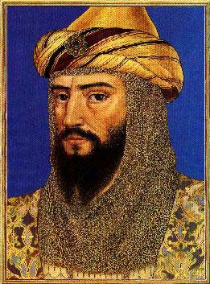
The greater jihad is a spiritual struggle centered on moral and ethical behavior. For example, if a Muslim teenager were struggling with the issue of sex before marriage, this would be considered a “greater jihad.” If you were wondering if you should experiment with drugs and alcohol, this would be a “greater jihad.” If you were tempted to cheat on an exam, or a loved one, this would be a “greater jihad.” The greater jihad has to do with right and wrong and the moral/ethical decisions we all make each and every day.
The lesser jihad is a violent struggle declared against the “infidel,” in this case a “non-believer” or “disbeliever” in the context of “one who does not believe in Allah.” Today in the Islamic world, Christians and Jews are considered to be the infidel because Christians and Jews do not believe in Allah and Muhammad. A Muslim mullah can declare a lesser jihad against enemies of Islam. For example, when the great Muslim military leader Saladin decided to take back Jerusalem from the Crusaders in 1187, Saladin declared a jihad against the “Christian Infidels.”
Saladin

