American History Name:
Date:
Source: The Americans (2003) Block:

The Cold War at Home
In the early years of the Cold War, many Americans believed that there was good reason to be concerned about the security of the United States. The Soviet domination of Eastern Europe and the Communist takeover of China shocked the American public, fueling a fear that communism would spread around the world. In addition, at the height of World War II, about 80,000 Americans claimed membership in the Communist Party. Some people feared that the first loyalty of these American Communists was to the Soviet Union.
Strongly anti-Communist Republicans began to accuse Truman of being soft on Communism. Consequently, in March 1947, President Truman issued an executive order setting up the Federal Employee Loyalty Program, which included the Loyalty Review Board. Its purpose was to investigate government employees and to dismiss those who were found to be disloyal to the U.S. government. The U.S. attorney general drew up a list of 91 “subversive” organizations (“subversive” means intending to undermine the power and authority of a government or institution); membership in any of these groups was grounds for suspicion.
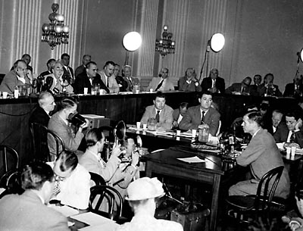
From 1947 to 1951, government loyalty boards investigated 3.2 million employees and dismissed 212 as security risks. Another 2,900 resigned because they did not want to be investigated or felt that the investigation violated their constitutional rights. Individuals under investigation were not allowed to see the evidence against them.
Other agencies investigated possible Communist influence, both inside and outside the U.S. government. The most famous of these was the House Un-American Activities Committee (HUAC). HUAC first made headlines in 1947, when it began to investigate Communist influence in the movie industry. The committee believed that Communists were sneaking propaganda into films. The committee pointed to the pro-Soviet films made during World War II when the Soviet Union had been an ally of the United States. HUAC subpoenaed 43 witnesses from the Hollywood film industry in September 1947. Many of the witnesses were “friendly,” supporting the accusation that Communists had infiltrated the film industry. For example, the movie star Gary Cooper said he had “turned down quite a few scripts because I thought they were tinged with Communistic ideas.” However, when asked which scripts he meant, Cooper couldn’t remember their titles.
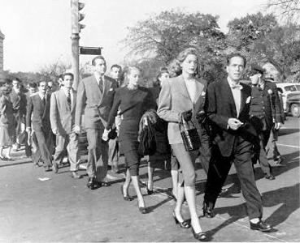
Ten “unfriendly” witnesses were called to testify but refused. These men, known as the Hollywood Ten, decided not to cooperate because they believed that the hearings were unconstitutional. Because the Hollywood Ten refused to answer questions, they were sent to prison. In response to the hearings, Hollywood executives instituted a blacklist, a list of people whom they condemned for having a Communist background. People who were blacklisted—approximately 500 actors, writers, producers, and directors—had their careers ruined because they could no longer work.
As Hollywood tried to rid itself of Communists, Congress decided that Truman’s Loyalty Review Board did not go far enough. In 1950, Congress passed the McCarran Internal Security Act. This made it unlawful to plan any action that might lead to the establishment of a totalitarian dictatorship in the United States. Truman vetoed the bill, saying, “In a free country, we punish men for the crimes they commit, but never for the opinions they have.” But Congress enacted the law over Truman’s veto.
