American History
Mr. Murray
Sources: J.A.S. Grenville, A History of the World in the 20th Century (2000); Kenneth C. Davis, Don’t Know Much about History (2003)

War in Europe: Background
The Great War disrupted and destroyed many lives on a scale never known before. More than 60 million men were mobilized and 8.5 million were killed, 21 million were wounded and in every town and village in Europe the blinded and maimed victims served as daily reminders decades after the war was over. In every town and village war memorials commemorate the names of those who gave their lives for their country. The war which involved millions and for which millions suffered was launched by the decision of just a few men negotiating and conspiring in secret. They bear a heavy responsibility. What made these men act the war they did? Were they aware of what they were doing, or did they just muddle into war through confusion and error?
There was a widespread illusion about the course the war would take. The troops left for the front in late summer believing that they would be home by Christmas. With the new mass armies it was thought that the war would be decided by the devastating battles fought at the outset. But no one expected that this would be just another war, like those of the mid-nineteenth century, ending with victors demanding some territorial and financial punishment on the losing powers. Everyone, however, knew what was at stake. Crumbling empires could not afford to be defeated or else they would be divided up into smaller nations. Alliances would soon drag nearly every European country into the war in some form. And, as always in war, death was inevitable.
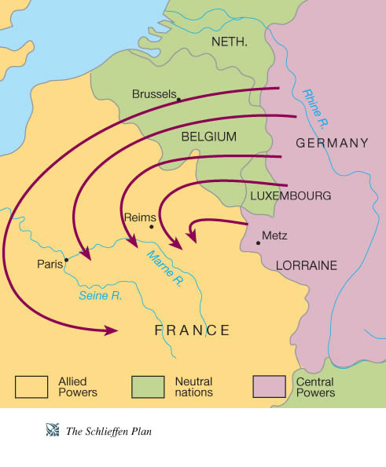
The assassination of Archduke Franz Ferdinand on June 28, 1914 was the spark that ignited a wave of mobilization throughout Europe. It was the final piece to a puzzle. Tensions and hostilities had been brewing in Europe for decades, and now there was reason to show one’s dominance, or exact revenge, or gain independence. Though the reasons and incentives for fighting may have been different, one thing was for sure: Europe would combust, and after the Great War it would be an entirely different place.
The Battle of the Marne, fought in September 1914, was the first battle of the war. A horrific event, total casualties for this single battle reach 500,000. Under a military design known as the Schlieffen Plan, the German army invaded France through in a hook like motion through neutral Belgium (remember, Great Britain joined the war due to its alliance with Belgium; when the Germans invaded neutral Belgium on August 4, 1914, the British join the war on the side of the Triple Entente). The Schlieffen Plan predicted that the German army would defeat the French in six weeks. The Germans swiftly moved into northern France and were making their way toward Paris but were stalled at the Battle of the Marne by a combination of British and French forces. British and French troops successfully stopped the German invasion and forced them into a retreat. The first Battle of the Marne demonstrated that a German victory on the Western Front would take longer than the 6 weeks it initially thought. It also led to the increase in German use of submarine warfare in an attempt to devastate the superior British navy. As submarine warfare expanded, war ships were not the only ones at risk, but passenger ships were now in danger of being torpedoed.
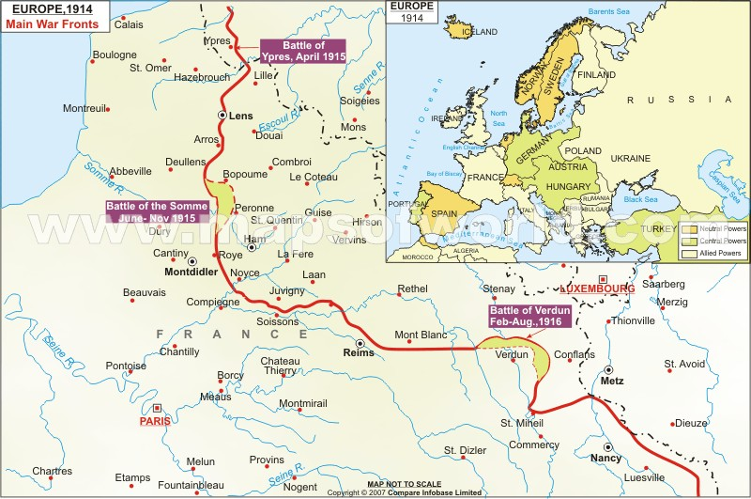
Other major battles at Ypres, Verdun, and Tannenberg would equally as devastating for Europe. Trench warfare led to stalemates (situations that were deadlocked; neither side was necessarily winning or losing) along the Western and Eastern Fronts. New powerful military technology meant that war was now more dangerous and deadly than ever. As a solution, both sides would dig trenches which would serve as protection against enemy assaults. In the Great War alone, over 12,000 miles of trenches were dug. Conditions in the trenches were appalling. Cramped quarters and poor sanitation led to major health issues among the troops. Rats and lice were common which meant the spread of disease was a common concern. The trenches flooded during rain storms leaving the men cold, wet, and susceptible. Men often suffered from exposure, frostbite, trench foot (a disease of the flesh caused by being wet and cold), disease, and constant attacks.
By 1917, two major events would change the outcome of the war: the Russian Revolution and American intervention. Both events would shape the future of the war and redefine the roles of major powers on the global stage.

