American History Name:
Date:
Sources: America, (2003); Kenneth C. Davis Don’t Know Much About History, (2003) Block:

American Fighting Force
World War II greatly changed the lives of the men and women who were uprooted from home and sent far away to fight for their country. More than 16 million Americans served as soldiers, sailors, and aviators in the war. They called themselves GI’s, an abbreviation for “Government Issue.”
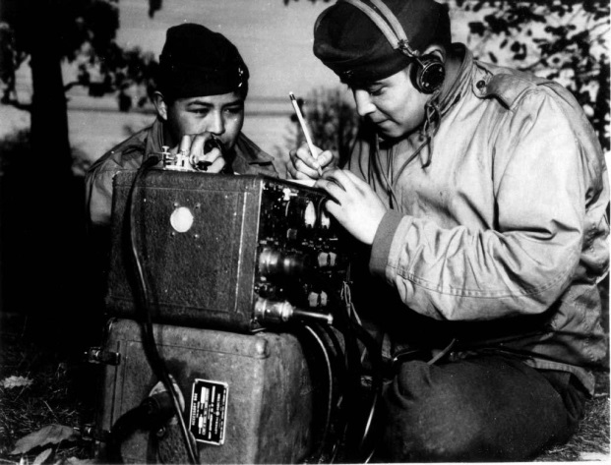
During the war, American GIs slogged through swamps, crossed hot deserts and turbulent seas, and flew through skies pounded by enemy guns. Soldier on the front lines often found their experience in the war was a daily struggle to stay alive. Between battles, the typical GI dreamed of home and blueberry pie. American soldiers knew that they were fighting to preserve the freedoms that they held dear.
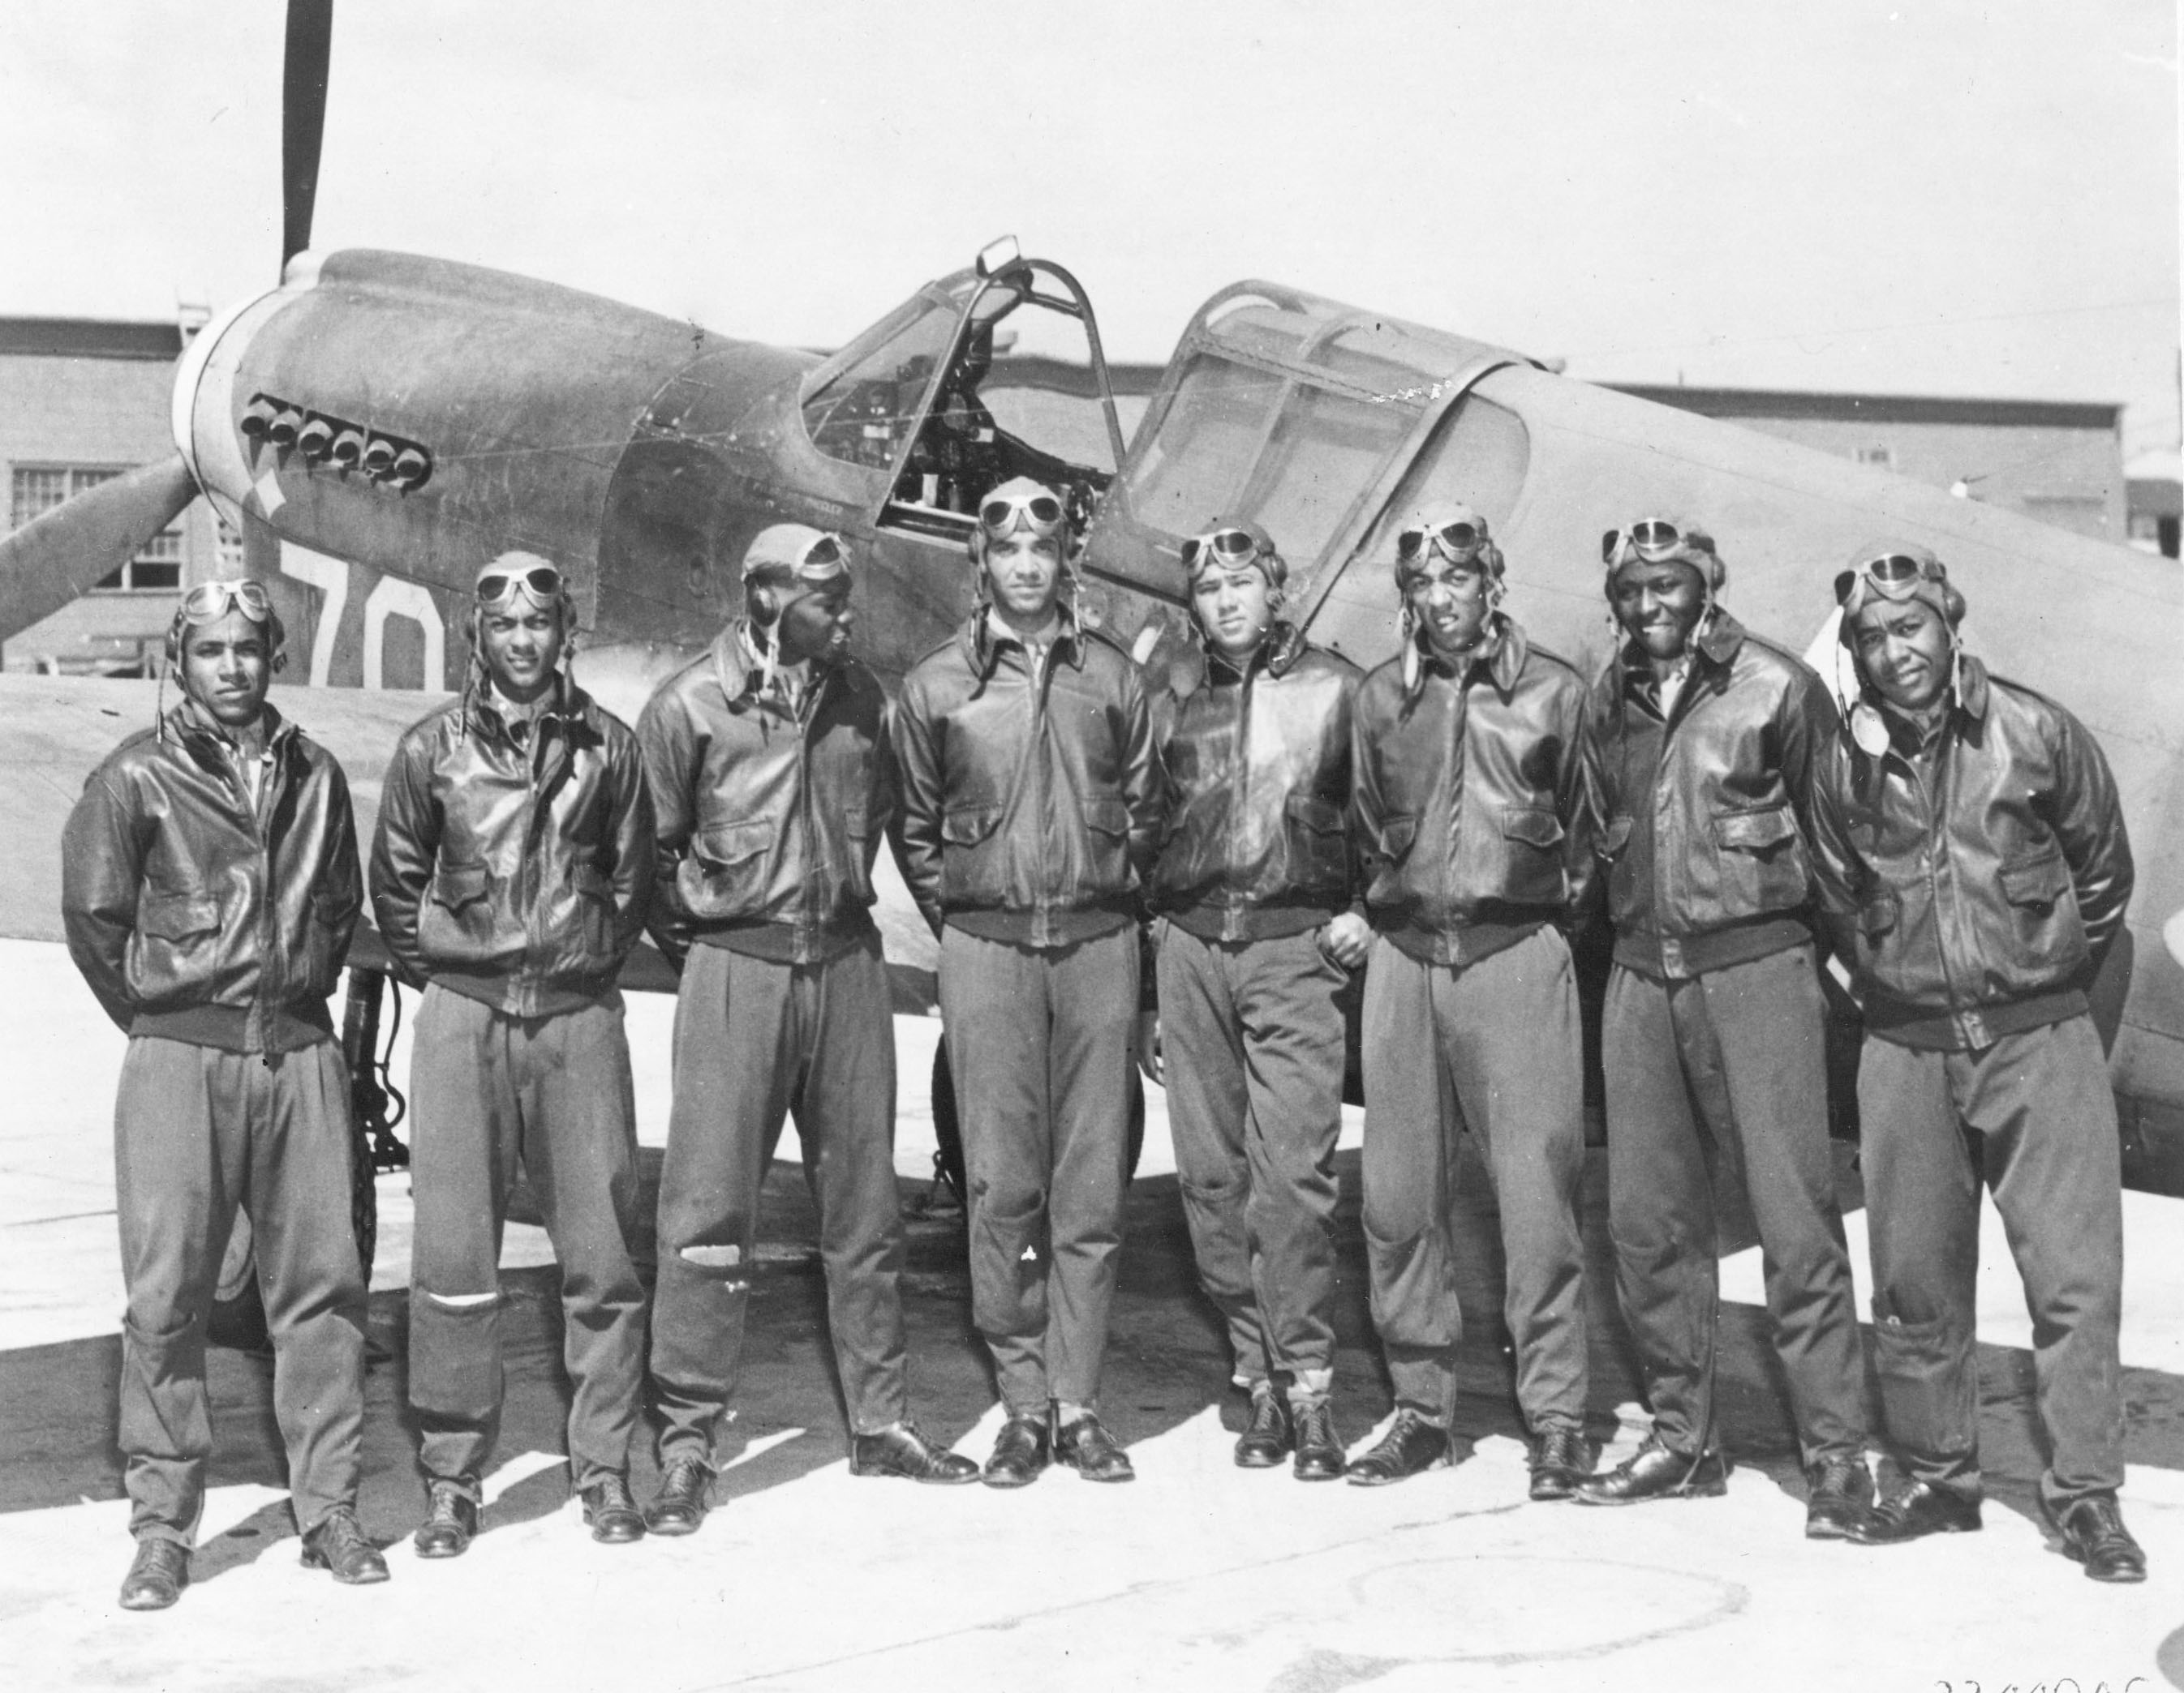
Americans from all ethnic and racial backgrounds fought during World War II. More than 300,000 Mexican Americans served their country, primarily in the army. Some 25,000 Native Americans also served in the military. A group of Navajos developed a secret code, based on their language, which the enemy could not break. The marines recruited more than 400 Navajos to serve as radio operators. These “code talkers,” as they became known, provided an important secure communications link in several key battles of the war. In addition to the 25,000 Native American who joined in the armed forces, many others migrated to urban centers to work in defense plants. Roughly 23,000 Native Americans worked in war industries around the country. Life in the military or in the cities was a new experience for many Native Americans who had lived only on reservations. They had to adapt quickly to white culture. At the end of the war, those who had moved away often did not return to reservation life. For some, the cultural transition brought a sense of having lost their roots.
Nearly a million African Americans joined the military. At first, officials limited most black troops to supporting roles. By late 1942, however, faced with mounting casualties, military authorities reluctantly gave African Americans the opportunity to fight. African Americans fought in separate units. One such group, called the Tuskegee Airmen, became the first African American flying unit in the United States military. In late 1944, heavy casualties forced the army to accept African Americans into some white combat units.
Not all who served in the military were men. By the war’s end, roughly 350,000 American women had volunteered for military service. Faced with a personnel shortage, officials agreed to use women in almost all areas except combat. Many worked as clerks, typists, airfield control tower operators, mechanics, photographers, and drivers. Others ferried planes around the country and towed practice targets for antiaircraft gunners.
Before the war, most women who worked for wages were single and young. They worked mainly as secretaries, sales clerks, household servants, and in other low-paying jobs traditionally held by women. Except for teaching and nursing, few women entered professional careers. Women with factory jobs usually worked in industries that produced clothing, textiles, and shoes, while men dominated the higher-paying machinery, steel, and automobile industries. Almost everywhere, women earned less than men.
Like World War I, World War II brought women into different parts of the work force. As men were drafted into the armed forces, many factory jobs fell vacant. These higher paying positions lured many women away from traditional jobs. They moved eagerly into manufacturing, particularly in the defense industries. Many women who had never worked outside the home also took jobs in the aircraft factories, shipyards, and other industrial sites that directly supported the war effort. The number of working women rose by almost one third, from 14.6 million in 1941 to about 19.4 million in 1944. Women at one point made up about 35 percent of the total civilian labor force.
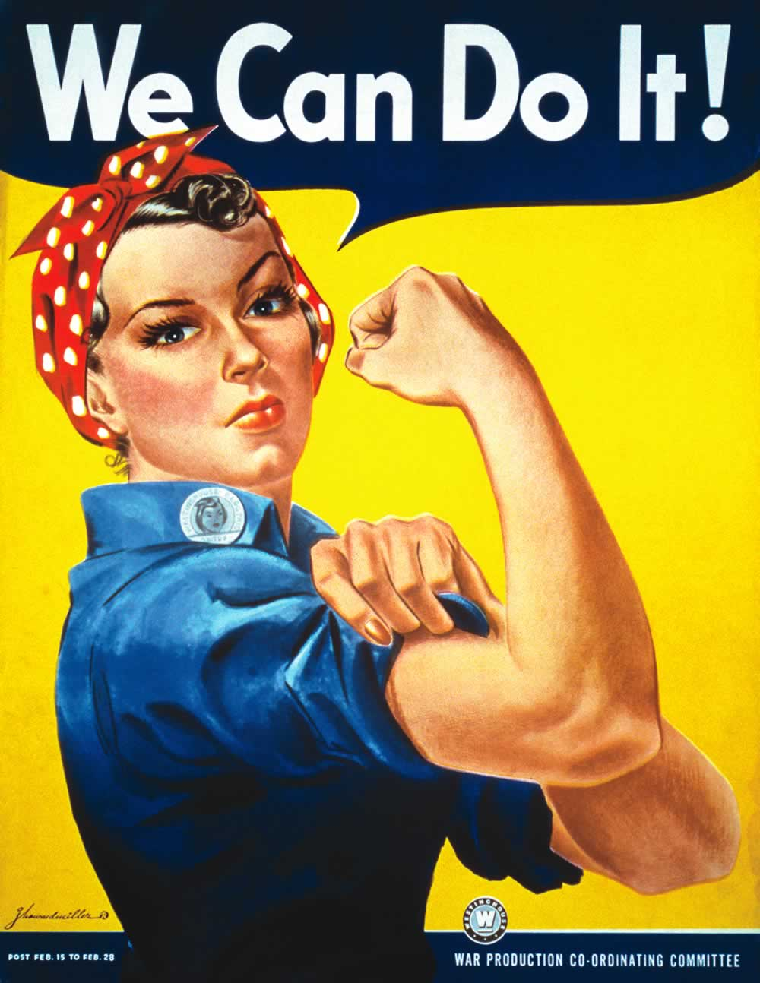
A popular song in 1942 told the story of a fictional young woman called Rosie the Riveter. Rose was a home front hero. She worked in a defense plant, driving rivets into the metal plates of aircraft, while her boyfriend Charlie served in the marines. The government used images of Rosie in poster and recruitment films of the 1940s to attract new women workers. In time, Rosie the Riveter became the popular name for all women who worked in war-production jobs, including riveters, steelworkers, and welders.
The government drive to bring women to defense plants assumed that when the war was over, women would leave their jobs and return home. War work was just “for the duration.” While many women wanted to continue working at the war’s end, the pressures to return home were intense. Returning servicemen expected to get their jobs back. As the economy returned to peacetime, twice as many women as men lost their factory jobs. Some women were content to leave once the wartime sense of urgency had ended. Others, however, had discovered new satisfactions in the workplace that made them want to keep on working. Some women also continued to work part time to bring in additional income. The return of servicemen posed a difficult question: do we give the jobs to the men who risked their lives for their country, or do we allow the minorities to keep the jobs they performed so well while trying to do their part for the war effort?

