World History Name:
Mr. Murray Date:
Absolutism in Europe and The Sun King Block:

“In absolute monarchies, there are no legal limitations to the monarch’s power (in real life, even absolute monarchs were restricted by informal factors, such as a weak personality, uncooperative nobles, or an unreliable arm). Absolutism in Europe was typically justified by the doctrine of divine right, according to which the monarch reigns by the will of God. (This is similar to the Mandate of Heaven in China, although divine right theory places no obligations on the monarch to rule justly.

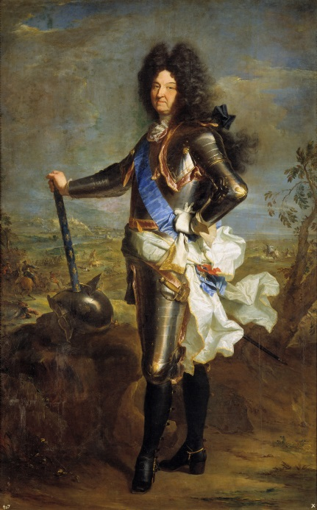
Europe’s archetypal absolute monarch was Louis XIV of France, the Sun King who rule from 1661 to 1715 (he ascended the throne in 1638, but was only five years old at the time). Louis XIV created a highly centralized bureaucracy and national economy. He broke the power of his aristocracy and made it obey him. He built the largest army and navy that Europe had seen in centuries. He turned Paris and his palace of Versailles into grand, impressive centers of power. In many ways intelligent, forceful man who used his extensive powers to make France better-organized, better-run and mighty. On the other hand, he involved France in too many wars, damaging the economy he had word so hard to improve. Near the end of his reign, he persecuted French Protestants, to whom his grandfather had guaranteed religious freedom.

France remained an absolute monarchy until the French Revolution of 1789. Other countries created similar regimes. In the late 1600s, the Austrian Habsburgs brought absolutism to the Holy Roman Empire. Leopold I built great palaces around Vienna, centralized his government and economy, and fought wars against the Turks. (In 1683, the Turks nearly destroyed Austria in the Siege of Vienna but were turned back; afterward, the Austrians and their allies pushed the Turks steadily to the east.) The constant Turkish pressure on Austria’s eastern frontier provided a good excuse for greater imperial control. In the eighteen century, Maria Theresa and Joseph II carried on Austria’s tradition of absolutism.
The small but militarily powerful German state of Prussia became an absolute monarchy during the late 1600s and 1700s. Frederick the Great (1740-1786)–a great general as well as a skilled ruler–was one of the most effective monarchs of his time. His victory over Austria, France, and Russia during the Seven Years’ War (1756-1763) is considered one of the greatest military triumphs in European history. However, the price Prussia paid for Frederick’s talents was greater dictatorship and decreased freedoms.

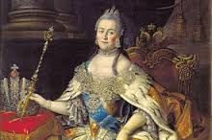
The largest nation in the world, Russia, also emerged as an absolute monarchy. Thanks to Moscow’s tzars, Russia already possessed a tradition of strong central authority. It was, however, economically, culturally, and scientifically backward compared to the West. (One effect of Mongol rule had been to cut Russia off from Europe during the Renaissance.) During the late 1600s and early 1700s, Peter the Great not only centralized political power but forced rapid, Western-style modernization on Russia. He also changed Russia’s geopolitical orientation. Earlier, Russia had been mainly isolated from Europe and concerned with events in Asia. However, by fighting and winning a long, hard war with Sweden, Peter gained a permanent place for Russia as Europe’s great power of the east. It became more European in nature, although never completely so. The other great absolute ruler of the eighteenth-century Russia was Catherine the Great, who gained an international reputation of her intellectual achievements and military conquests. Much longer than other European states, Russia kept in place an oppressive system of serfdom.”

THE SUN KING: LOUIS XIV

Louis XIV and the Palace of Versailles:

The absolute power of the French king was first challenged by the Parisian Parliament (French for parliament) during the 17th century, however the Parliament actually had very little power. The Parliament was not representative of the French people, but they were eager to limit the king’s power to set taxes. France’s wars with a number of other European countries (most notably Spain and the Holy Roman Empire) had become quite costly and so taxes were very high.
One of the first major revolts against the French monarchy was a result of these wars and the taxes they had caused. This revolt was called the Fronde, which literally means “slingshot”, and took place from 1648-1653. The name was taken from the slingshots used by Parisian children from the slums to toss mud at passing nobles in their carriages. This mud annoyed the noble riders in the carriages, but it never stopped them from using the streets of Paris. Much like the mud, the Fronde was annoying, but it did not stop the king of France from doing as he pleased. Ultimately, the Fronde was a failure; no limits were placed on the absolute power of the French kings.
The Fronde technically took place during the reign of Louis XIV, though he was only five years old when he became king in 1643 and so his mother, Anne of Austria, ruled in his place until he came of age. Though Louis XIV was the king and Anne of Austria was ruling in his placed, for the next 18 years (from 1643 to 1661) the real ruler of France was Cardinal Mazarin, who served as Chief Minister of France. Cardinal Mazarin was involved in putting down the Fronde, and Anne of Austria entrusted him with many of the details of running France. They essentially ruled as co-rulers and were so close that rumors flew that they had, in fact, married and that Louis XIV was Mazarin’s son, though there was no evidence to support either claim. When Mazarin died in 1661 the people were shocked that Louis XIV himself took control of the French government. Louis XIV decided that he would serve as his own prime minister and so, for the next 54 years, he was at the center of Europe, its wars, and its life. Because of his influence, this period has been called the Age of Louis XIV.
Louis XIV was the greatest of the absolute monarchs; he was called the Sun King. He looked and acted like a king. He loved praise and flattery. He loved, and surrounded himself with, pictures and statues of himself. He believed that he was the greatest of all rulers: a king of kings.
Louis XIV disliked Paris; he hated the narrow streets and was afraid of the crowds of people. He never forgot the fear he felt as a small boy during the Fronde as mobs ran the streets of Paris. He wanted to get out of Paris, no matter what the cost, and so Louis XIV insisted on moving on moving the French court ten miles from Paris to Versailles (pronounced ver-sigh).
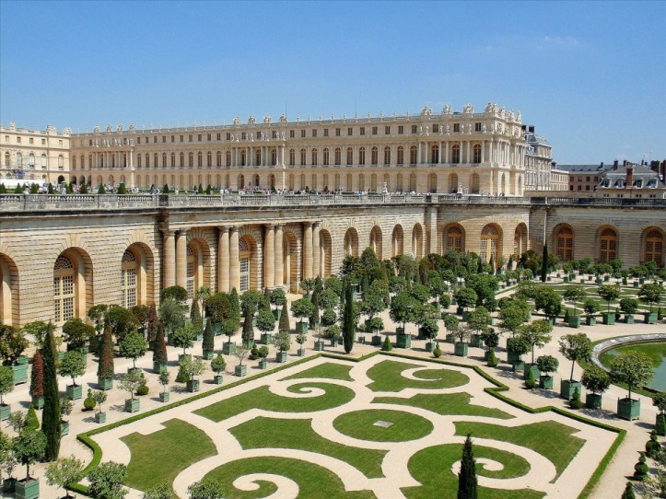
At Versailles, Louis XIV built a palace worthy of a Sun King. It was, and remains, the finest palace in the world. It took over 30 years to complete the Palace of Versailles. As many as 35,000 people worked on it at one time and hundreds of workers lost their lives. Louis XIV destroyed the records of expenses before he died, so nobody knows how much it cost to build.
___________________________________________________________________________________________

Two Counts Discuss Versailles (1691):

“Count Chaumont!” called Count Rideau, as he recognized a familiar face in the crowd that filled the great Hall of Mirrors. Rideau walked quickly to greet his old friend. “When did you arrive at Versailles? I see that Louis finally forced you to come here. How do you like it?”
“It’s great to see you again, Rideau,” said Chaumont as they greeted each other. “It’s been a long time. How do I like it? That’s a fine question coming from you. You warned me about how dull and boring it was here. Remember how you kept writing me not to come because it wasn’t my kind of life?”
“I suppose,” said Count Rideau, “you felt that I was trying to hide the truth from you. You must have had the idea that I would not want to share the fun of Versailles with my best friends.”
“No, Rideau. I believed you. I admit that I did have some doubts about your stories at the beginning, but why would you have wanted to keep me away from here? Now I’m sure that it was for my own good. I’ve been at Versailles only three days and already I wish I were back home!”
“Now you realize that everything they say about Versailles is true. You can be happy here if you can learn to do exactly as you are told. You’ll find plenty to eat and drink. There are many good looking women. Keep your eyes open. But…stay away from the gambling. You can lost your shirt. The king will pay for the gambling losses of his closest friends, but you are far removed from that position.”
“Thanks for the good advice,” said Chaumont. “Tell me, do you see the king very often? You’ve been here for three years. Are you at all close to him now? Will he talk to me?”
“Slow down…not so fast,” said Rideau, laughing, “One question at a time. Only the most powerful nobles are close to the king. That doesn’t include people like you and me. I haven’t even reached the high position of handing the king his shirt or pants. The best I’ve been able to do so far is watch him wash his face a few times. Oh, and once I saw him put on his wig. Only his favorites actually hand him food. I have never gotten that close. But can he eat!”
“I’m sorry,” said Chaumont, “but I must confess that I just don’t understand what you’re talking about. What’s the big deal about handing the king his underwear and watching him dress? Who wants to watch him eat or bring in his food? We’re not servants! We’re nobles! This is ridiculous!”
“Chaumont, you have to understand that Louis isn’t just the king of France. He is the sun and the moon and the stars! He is the center of our world. We nobles are here to honor him, to do everything to make him happy.”
“Does being dressed and undressed by his nobles make him happy?” asked Chaumont.
“You’ll find out,” answered Rideau. “There is a set way of doing everything at court. These things please the king. He likes doing the same thing at the same time each day. This is his life. You’ll see: someday you’ll be happy to do things for the king that you now think are so silly. Who knows, someday he may even speak to you! But…don’t expect it. He’s not a great talker. Some claim he says so little because then he won’t have a chance to say the wrong things. Do you know that he has been his own prime minister since Mazarin died? He tries to do too much. Not even the Grand Monarch the Sun King can run a country as large as France all by himself. He wants to know everything, sign everything, it is impossible.”
“With all the parties and games going on around here, when does the king find time to govern?” asked Chaumont.
“Don’t let appearances fool you,” said Rideau. “Yes, he loves all the parties and rituals at Versailles, but he spends a good eight hours a day on the business of running the country. Believe it or not, he is a hard working king.”
“Isn’t he afraid to make mistakes?” asked Chaumont.
“My dear Chaumont, the king makes no mistakes. He is the all-powerful ruler. He is the image of God on earth. He thinks of himself as the greatest of men-and we nobles agree! That’s why he took the sun as his emblem. Our King Louis XIV is the source of our light and life!”
“But that’s blasphemy!” cried Chaumont. “That’s disrespectful for God – to compare Louis with God! After three years in Versailles you are a stranger to me. I don’t understand you. You were my closest friend, and now…”
“Chaumont,” said Rideau coolly, “I am very sorry that I disappoint you. Three years is a long time. What I said is what the people at the court are saying. They are not my ideas. Someday soon you too will understand. You will change. You will earn your place here. This will be your entire world. You too will say that Louis is a great king. You will see his pockmarks and his warts, but you will learn to love him.”
“Please forgive me for shouting at you,” said Chaumont, much more calmly. “I must learn to accept things here. But, if Louis is such a great king, almost a god, why doesn’t he save the poor people from starving?”
“We know very little about life in the outside world,” replied Rideau. “That’s not our concern. Don’t work. Louis will take care of the people. Chances are that you know much more about what’s going on in the rest of France than I do. Please, tell me what you know.”
“Well,” said Chaumont, “Louis is a great spender. Taxes are very high. People say that the money goes in and out of the royal treasury faster than you can say, ‘Sun King’. But, the spending isn’t all personal. Let’s not forget all of his wars. It’s hard to think of a time when France, or should I say Louis, was not at war! Why does he have to fight war after war? First he wins some land and then he loses some land. He is bleeding our country to death!”
“Louis fights for the glory of France,” replied Rideau. “We will not let any nation push us around. Why should we? We are great!”
“Yes, but does he have to fight the world?” responded Chaumont. “Doesn’t France have enough problems? I could understand why Vauban built fortresses on our frontiers. I am all for defense, but do we always have to attack? Who needs the Spanish Netherlands? Why should we make secret deals with the English?”
“Think of it Chaumont, if you had great generals like Conde and Turenne, what would you do? Wouldn’t you attack? Why shouldn’t France become even more powerful?”
“Yes,” replied Chaumont, “a great country knows how to live in peace with her neighbors. A great king understands that his first responsibility is to his people. He doesn’t send them to die in wars. He doesn’t bleed them of their money.”
“What you are saying about our king makes sense to you as a newcomer to Versailles,” said Rideau, speaking quietly once more. “But wait…you’ll soon be caught up in the life and death of Versailles. The king will be the center of your world. You will accept whatever he does and whatever happens here. This is all you will know. You will change, believe me, I did. You will respect and appreciate Louis. He is human. He may not be perfect, but he is the very best king that Europe has ever had. He is a king of kings!”
“You mean that he is the best king that France had at this moment,” said Chaumont, also very quietly. “Perhaps he is strong enough to hold our country together during his lifetime, but what will happen to France and Europe after he dies? Who will pay for all of his waste, for his extravagances? Who will account for all the peoples’ suffering?”
Rideau thought for a moment. “We will all pay, I suppose. France cannot afford another Louis XIV.”

