American History Name:
Mrs. Barnes Date:
Sources: America, Prentice Hall (2003) Block:

The Threat of Communism
“Normalcy,” Warren G. Harding’s campaign motto, appealed to Americans in 1920 because events within the country and abroad seemed anything but normal. Upheaval in faraway Russia and a series of strikes and bombings at home convinced people that political violence posed a real threat to the United States.
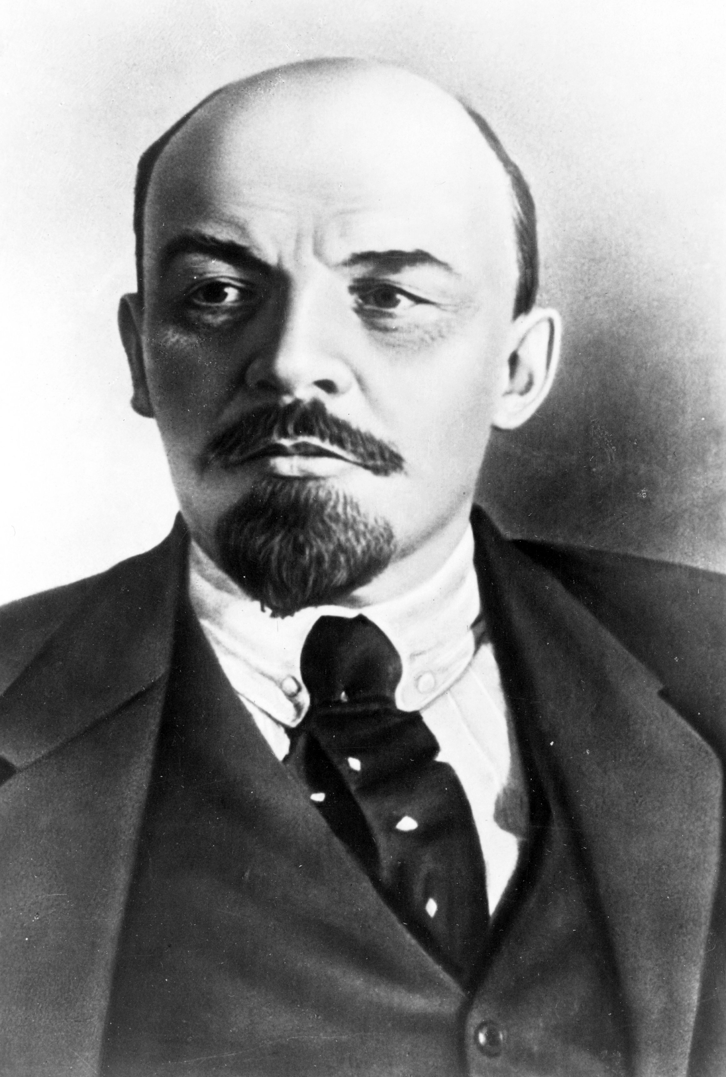
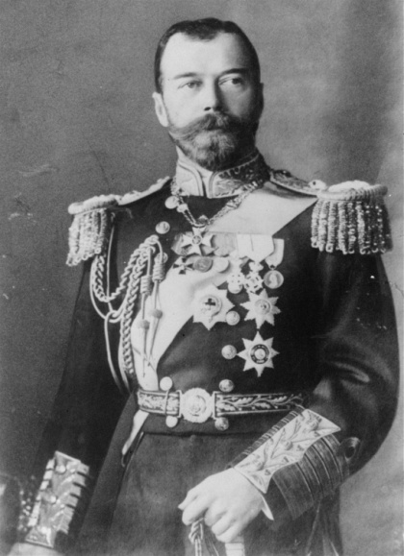
The political situation in Russia dramatically changed in 1917. Formerly ruled by a Czar, a male monarch or emperor, Russia was in a steady decline. Mostly due to poor decisions made by then Czar Nicholas II, Russia suffered from devastating casualties during World War I and severe food shortages which left his country weak and volatile. Czar Nicholas II was forced to abdicate, relinquish power, and on November 6, 1917, Vladimir I. Lenin and his Bolshevik followers overthrew the government and began to sow the seeds of a Communist state. In 1922, the Bolsheviks, who adopted the red flag as their symbol, established the Union of Soviet Socialist Republics (USSR), or the Soviet Union. Lenin made communism the official ideology of the USSR. The ideology was openly hostile to American beliefs and values, such as capitalism, private ownership, and First Amendment freedoms. For Lenin and his followers, communism meant the following:
- The government owned all land and property
- A single political party controlled the government
- The needs of the country always took priority over the rights of individuals
For communism to survive, Lenin believed it had to be spread throughout the world. Russia had long been agrarian. Peasants made up 80 percent of Russian population in 1917. To the working class, which had long been oppressed by czarist rule, communism had appeal. It promised a classless society in which the wealth was shared among all citizens according to their need. However, once put into practice, communism became something far different. Russia’s intentions to spread communism alarmed many Americans. Americans became weary of European countries and blamed them for beginning World War I. European immigrants who came to the United States were feared to be Communists and other radicals. After a series of bombings sent through the U.S. mail, anti-Communist sentiment was riled up in American society. The United States was in the grip of a Red Scare, an intense fear of Communism and other politically radical ideas.
In June 1919, bombs exploded in several cities. One explosion severely damaged the home of A. Mitchell Palmer, the Attorney General of the United States. Although Palmer escaped injury, the bombings convinced him that radicals were conspiring to overthrow the government. He began a campaign to identify and root out groups whose activities posed a “clear and present danger” to the country. Later that year the Justice Department, headed by Palmer, set up a special force to conduct raids and arrest suspected “subversives,” or people trying to subvert or overthrow the government. Targets included Communists, Socialists, and anarchists.
On January 2, 1920, federal agents in 33 cities arrested thousands of suspected radicals, and without evidence, charged them with anarchy. Most of the suspects had been born overseas. Many were completely innocent. Still, more than 500 of them were later deported, or sent back to their homeland. At first, Palmer received strong support for his actions. But the Red Scare, coupled with the Palmer raids sparked a frenzy.
The Red Scare plated a crucial part in one of the most controversial events in U.S. history. The story began on April 15, 1920, when gunmen robbed and killed the guard and paymaster of a shoe factory in South Braintree, Massachusetts. A few weeks later, police arrested two Italian immigrants in connection with the crime.
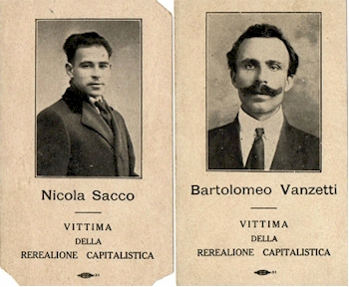
One, Nicola Sacco, was a shoemaker, and the other, Bartolomeo Vanzetti, was a fish peddler. Both of them were also anarchists. Police found guns on both men when they were arrested; Sacco’s gun was the same model used in the crime. Yet, many Americans suspected that the two men were arrested mainly because they were immigrants with radical beliefs. The case drew international attention and controversy. After a trial that many observers called unfair, a jury found Sacco and Vanzetti guilty. Their lawyers appealed the case to higher courts again and again for years, but the convictions were upheld. The two men were sentenced to death in April 1927, and despite mass protests, they died the electric chair four months later.

