American History Name: Date:
Pacific Theater Timeline Block:
Source: Kenneth C. Davis, Don’t Know Much About History
1941
December 7, 1941—One day after President Roosevelt appealed to Emperor Hirohito of Japan to use his power and influence to avoid war, the Japanese attacked Pearl Harbor, a major U.S. naval base in Hawaii, killing 2,403 American soldiers, sailors, and civilians. Nineteen ships and 292 aircraft were destroyed or damaged. Defying all American expectations of their military capabilities, the Japanese made simultaneous strikes on Guam, Midway, and British bases in Hong Kong and Singapore. Japan declared war on the U.S.
December 8, 1941—Addressing a joint session of Congress, Roosevelt asked for a declaration of war on Japan. The Senate vote was unanimously in favor; the House approved 388-1, with pacifist Jeanette Rankin, the first woman elected to the House, the lone dissenter.
1942
April 9, 1942—75,000 American and Philippine troops surrender to the Japanese after a lengthy resistance to a Japanese force who heavily outnumbered the Allied troops. The captives were marched over 100 miles in the infamous Bataan Death March, during which thousands of prisoners were executed or died of starvation and thirst before they reached the Japanese prison camps. A few weeks later, General Wainwright was captured by the Japanese, surrendering all American forces in the Philippines.
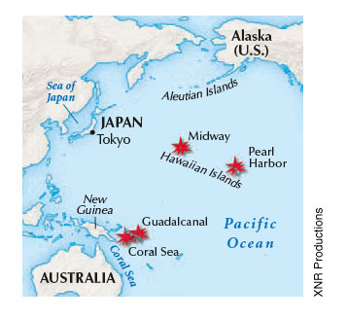
May 4-8, 1942—The Battle of the Coral Sea. In an early turning point off New Guinea, U.S. Navy planes severely damaged a Japanese fleet, forestalling a Japanese invasion of Australia. For the first time in naval history, ships in battle did not engage each other directly; all of the fighting was carried out by planes launched from aircraft carriers.
June 3-6, 1942—The Battle of Midway. In a major naval confrontation off the small North Pacific Island, the U.S. Navy won a crucial battle in the Pacific war. Although the U.S. carrier Yorktown was damaged, the Japanese lost 4 carriers and many of their best-trained pilots, and the Japanese naval advantage was eliminated, ending the threat to Australia. By this time the Japanese controlled an enormous area extending westward to Burma, north to Manchuria, south to New Guinea, and including the small islands of the Pacific. Their territory represented about 10% of the earth’s surface.
August 7, 1942—In the first U.S. offensive of the war, marines land on Guadalcanal in the Solomon Islands, northeast of Australia. It is the beginning of a two-pronged assault aimed at dislodging the Japanese from islands that will provide stepping-stones for an eventual invasion of Japan. The war in the Pacific has been given a strategic backseat to the war in Europe, and American Pacific forces would often been poorly supported, lacking ammunition and other supplies. This is the case on Guadalcanal, the first in a series of bloody, savagely fought battles in the Pacific.
1943
November 20, 1943—The Battle of Tarawa. An island near the equator, the Tarawa atoll (island) possessed an airstrip, an important prize in the Pacific fighting. Using British guns captured at Singapore, the Japanese were well defended on the small island of Betio, about half the size of Central Park. Ignoring islanders’ warnings of tricky tides, the landing’s commanders sent in waves of marines who were trapped before reaching the beaches. The marine’s casualties totaled 3,381, but the airstrip was eventually taken.
1944
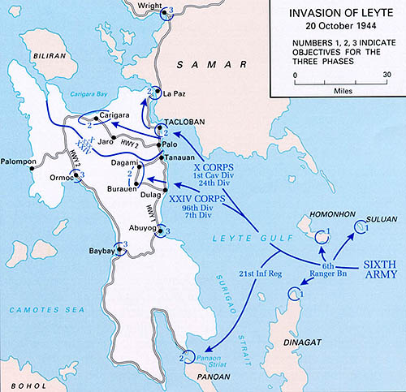
January 31, 1944—After taking control of the airstrip at Tarawa, the U.S. amphibious invasion force under admiral Nimitz continued its step-by-step sweep into the North Pacific with an invasion of the Marshall Islands.
October 20, 1944—Battle of Leyte Gulf (Philippines). General Douglas MacArthur, in the now-famous photograph, wades ashore at Leyte Island, the Philippines, fulfilling his promise to return. Three days later, the Battle of Leyte Gulf resulted in a major Japanese naval defeat. The Japanese then began to resort to the infamous kamikaze suicide attacks, in which Japanese pilots attempted to crash their explosive-laden planes into American ships. Kamikaze attacks resulted in the loss of some 400 ships and nearly 10,000 American seamen.
1945
February 1945—A month-long siege in the Philippines ends with U.S. troops retaking Manila (Philippines).
March 9, 1945—As U.S. planes began to bombard Japan more heavily, Tokyo was attacked by a massive firebombing. Two thousand tons of gasoline-gel and oil-gel incendiary bombs were dropped on the city, beginning a firestorm, fanned by winds, that the U.S. Strategic Bombing Survey called “conflagration” (meaning fire, or inferno). The water in Tokyo’s shallow canals actually boiled. The U.S. Strategic Bombing Survey estimated that “probably more persons lost their lives by fire in Tokyo in a six-hour period than at any in the history of man.” More than 100,000 men, women, and children died in Tokyo on this night, another million were injured; a million lost their homes. In the next few days, the cities of Magoya, Osaka, and Kobe were also firebombed until the U.S. Air Force literally ran out of bombs. In ten days, the firebombings killed at least 150,000 people and burned out the center of Japan’s four largest cities.
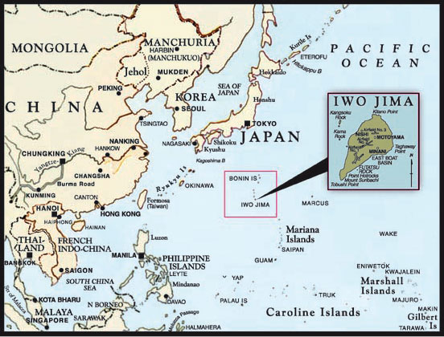
March 16, 1945—Iwo Jima. A month-long struggle for this rocky, eight-square mile piece of volcanic island came to an end. Possessing Japan’s last line of radar defense to warn against American air attacks, Iwo Jima is a strategically significant prelude to the invasion of Okinawa. The combined naval and ground attack began one of the most terrible and hard-fought battles of the war. The U.S. military considered the use of poison gas shells before sending in troops but decided against it, probably because of the outcry against poison gas in World War I. The famous image of the six marines—three of whom would die on Iwo Jima—raising the flag atop Mount Suribachi became an American icon. Losses on both sides were horrifying, with the U.S. Marines suffering 6,821 killed and more than 21,000 wounded; the 50 percent casualty rate was the highest in marine Corp history. More than 20,000 Japanese defenders died while only 1,083 were taken prisoner.
April 1, 1945—In the next stepping-stone, U.S. troops invaded Okinawa on Easter Sunday, or, as the soldiers ironically noted, April Fool’s Day. The Japanese allowed the troops to land, and then systematically attempted to destroy their naval support, beginning a fight that would last almost three months, the bloodiest battle of the Pacific, which would eventually cost 80,000 American casualties.
June 21, 1945—Okinawa fell. The Japanese have lost 160,000 men in fighting on the island; more than 12,500 Americans died on Okinawa.
July 5, 1945—General MacArthur completed the recapture of the Philippines; 12,000 Americans died in the ten-month fight for the islands. With the reconquest of the Philippines and the securing of Okinawa as a base, the United States began their plans for an invasion of Japan.

