World History Name:
Mr. Murray Date:
The Geography of Japan Block:

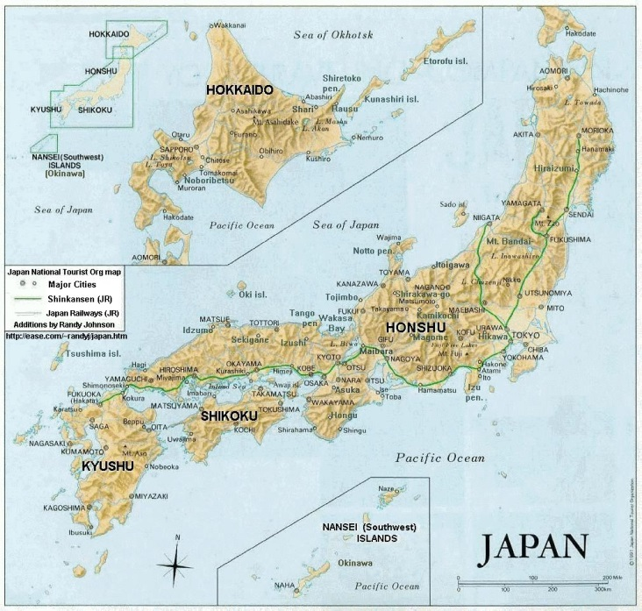
Close your eyes and try to picture the most beautiful sunrise imaginable. Imagine a bright orange ball slowly rising out of a deep blue ocean and watch how the sky changes color from grey to pink to orange to Colorado-blue. Every day the sun rises out of the sea and every day the sun sinks into a glorious sunset. To the ancient Japanese, the sun was the living, breathing goddess Amarterasu (ah-maat-tour-ah-sue). The Japanese believed the sun was the most powerful of all of their tens of thousands of kami, or spirits. And to the Japanese, the sun and the sea were essential to understanding the geography of perhaps the most beautiful group of islands in the world: Nihon (state of Japan).
Geography is destiny. Who we are, what we become and how we think can all be traced back to where we live. This concept is called geopsychology. Geopsychology is the relationship between geography and behavior. Japan is a country of absolutely breathtaking beauty: emerald green valleys, surrounded by pine-carpeted mountains; rugged mountain peaks; rocky and windswept beaches.
According to a Japanese myth, the home islands were created centuries ago by the Japanese sun goddess Amaterasu. In the heavens above, the sun goddess was creating a katana, the deadly sword of the samurai. After forging the weapon, the sun goddess dipped the red-hot steel of the blade into a pool of cool water. Four absolutely perfect droplets of water fell off of the new blade to the earth below, and these four drops of water became the four major islands of Japan: Hokkaido, Honsu, Hyushu, and Shikoku. Amaterasu then populated these islands with a perfect race, stronger, more beautiful and more intelligent than any other people in the world. This master race concept spawned by the gods and superior to all others has always been a major part of Japanese society and culture. To this day, the Japanese view themselves as a people apart, separated from the rest of the world by wind and sea—a people special and unique among all peoples of the world. Modern sociologists point to the fact that the modern nation-state of Japan has one of the purest gene pools of any people on the planet, a country where less than 1% of the population is foreign. Because of the isolation of Japan and a proud sense of national identity, the Japanese traditionally have a strong distaste and dislike for any foreigners. This remains true to this day.
The key to understanding much of Japanese history is an appreciation of the struggle for land. Ninety percent of the Japanese population lives on 15% of the land. Four-fifths of Japan is mountainous. When we close our eyes and imagine Japan there are two powerful images that come to mind: mountains and sea. No one in Japan lives further than 70 miles away from the ocean, so the Japanese are oriented to the sea. Living on four major islands, Japanese civilization evolved without the ever present fear of foreign invasion. Japan is blessed with natural defendable boundaries, with ocean on every side. Japan is an island state composed of four major islands. From North to South are the islands of Hokkaido, Honsu (the largest, with the largest population), Kyushu, and Shikoku. Japan stretches over 2300 miles oriented from northwest to southeast. If you lay a map of Japan on a map of the United States, Japan would stretch from Maine in the north, to Florida in the south. The bulk of the Japanese population lives on the island of Honsu whose climate is almost identical to that of North Carolina. Like the United States Japan has an extremely diverse climate. The island of Hokkaido looks and feels much like the state of Maine while the majority of the population on Honsu live in a climactic zone similar to the American southeast (think North Carolina, Florida, etc.). The 1500 islands south of Shikoku have a climate similar to Hawaii. Hokkaido receives over 5 feet of snow every year. The winter winds blowing west out of Siberia pick up moisture from the Sea of Japan and dump this in the form of raging blizzards along the northeast coast of Japan. Yet, due to the volcanic mountains that run like a spine along the entire length of northern Japan, the contrast of climates can be striking: snow, grey and gloom on the eastern side, while there is bright sun and bare ground on the west side facing the Pacific. In the north, winters bring tons of snow; in the south, rain and bone-chilling humidity. To stay warm and to hear their food, every home had a small fire-pit called a hibachi. A national pastime is bathing. Because the Japanese islands were volcanic in nature, Japan has tens of thousands of natural, warm water springs called jacuzi. Meditating, drinking saki, and bathing in the jacuzi is still to this day a national obsession.
The western side of the southern islands that juts into the Pacific Ocean has a subtropical feel: moist, humid, and war with over 100 inches of rain a year. There is only a single extensive plain in Japan—the Kanto Plain around Tokyo—which stretches a mere 120 miles in its longest direction. Otherwise the rest of Japan lives on small seacoast floodplains, in narrow river valleys and in a few basins in the mountains, each separated by rugged hills or steep mountains.
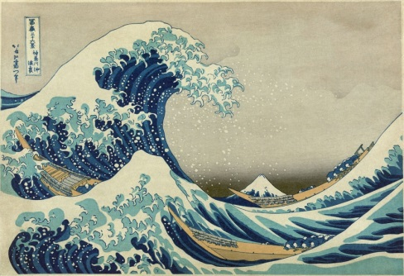
So how should we see Japan in our mind’s eye? This is a country of absolutely breathtaking beauty; rich, green valleys surrounded by rugged pine-covered mountains; snow-covered peaks; jutting seemingly straight up out of the ocean; a sea of pink cherry blossoms in the spring as far as the eye can see; brilliant forests of red and orange trees in the fall with long stretches of cool, sunny days; days, weeks, and months of rain during the rainy season, windswept beaches and glorious sunrises.
Typhoons (called hurricanes in the Atlantic) have conditioned the Japanese to except natural disasters and to accept these awesome forces of nature (kami) in courageous silence. This sort of fatalism—a feeling that our lives are controlled by forces we cannot control—might be called a “typhoon mentality.” Because Japan is located in the Pacific “Ring of Fire” where volcanoes, earthquakes, and tsunamis (harbor waves) are extremely common, the Japanese have a fatalistic acceptance of nature’s horrible power, as well as an incredible capacity to rebuild and move on after disaster strikes. Because of the islands stunning beauty and close relationship to mountains and ocean, the Japanese have an incredibility deep connection to nature, thus the Japanese worship of kami. The world is harmoniously balanced. Man and nature are one.

