World History
Mr. Murray
Study Guide: Paleolithic Man,
Neolithic Revolution and Mesopotamian Civilization

Identification: Who? What? Where? Why Important?

- 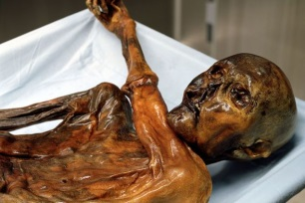

- 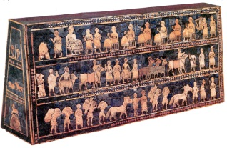

- 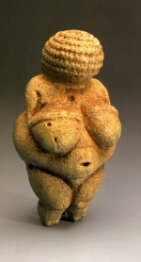

- 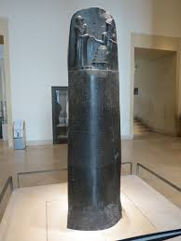

- 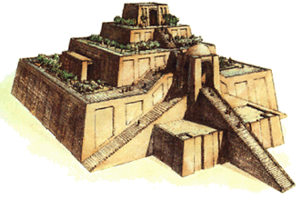
People, Places, Events, Concepts

Paleolithic

Mesolithic

Neolithic

Neolithic Revolution

Carbon Dating

Hominid

Lucy

Australopithecus

Homo Erectus

Neanderthals

Homo Sapiens Sapiens

“Out of Africa” Theory

Catal Huyuk

Jerico

Mesopotamia

Indus Civilization

Shang Dynasty

Sumer

Akkad

Babylonia

Assyria

Polytheism

Sargon the Great

Ashurnasirpal II

Sennacherib

Esarhaddon

Ashurbanipal

Neo Babylonian Empire

Nabopolassar

Nebuchadnezzar II

Babylonian Captivity

Essential Questions

What was the role of women and men during the Paleolithic Age?

How did our ideas of human sexuality develop during the Paleolithic Age?

Explain, in basic terms, what life was like for man during the Paleolithic Age?

What role did fire have in the development of man?

What did cave art of early man depict and tell us?

How was the Neolithic Revolution a blessing and a curse for mankind?

Where in the world did the earliest Neolithic communities develop? (Four Main Areas)

What are the eight components of civilization?

How did the Tigris and Euphrates play an important role in the development of Mesopotamian civilization? ( Think about the 8 characteristics of civilization)

How did religion play a role in Mesopotamian civilization?

What were the major accomplishments of the Sumerians?

Why was the Akkadian civilization short lived yet very influential?

What did Hammurabi’s code tell us about ancient Babylonian society?

How did Assyria come to dominate the “four corners of the known universe”?

Why was the development of cuneiform important for the Mesopotamians?

Who were the Phoenicians and why were they significant?

Question: How do historians construct history? What are the challenges of reconstructing
the past?
Point: Answer the prompt directly in a topic sentence.
Evidence: Prove the answer to the Point with Evidence- a fact, detail, quote or example.
Analysis: Use analysis to explain how the fact, detail, quote or example proves the answer. (So what? Why important?)
Evidence: Prove the answer to the Point with Evidence- a fact, detail, quote or example.
Analysis: Use analysis to explain how the fact, detail, quote or example proves the answer. (So what? Why important?)
Evidence: Prove the answer to the Point with Evidence- a fact, detail, quote or example.
Analysis: Use analysis to explain how the fact, detail, quote or example proves the answer. (So what? Why important?)

Question: How does diffusion of ideas impact a society? Why are some ideas preserved over time and others not?
Point: Answer the prompt directly in a topic sentence.
Evidence: Prove the answer to the Point with Evidence- a fact, detail, quote or example.
Analysis: Use analysis to explain how the fact, detail, quote or example proves the answer. (So what? Why important?)
Evidence: Prove the answer to the Point with Evidence- a fact, detail, quote or example.
Analysis: Use analysis to explain how the fact, detail, quote or example proves the answer. (So what? Why important?)
Evidence: Prove the answer to the Point with Evidence- a fact, detail, quote or example.
Analysis: Use analysis to explain how the fact, detail, quote or example proves the answer. (So what? Why important?)

