World History
Mr. Murray
Alexander the Great and Roman Republic Study Guide

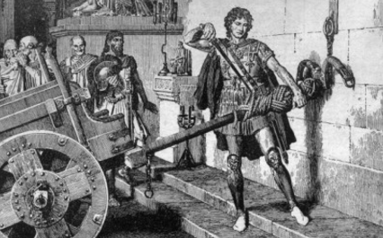

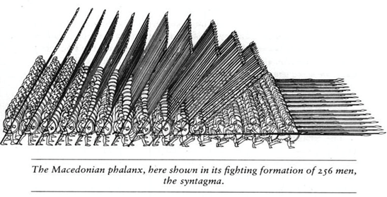

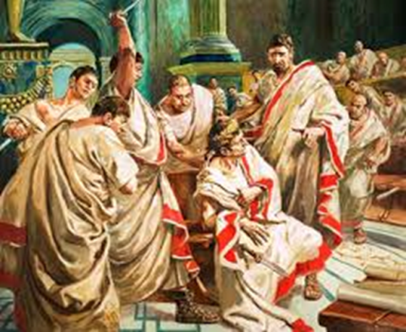

Name:
Date:
Block:

Philip II

Macedonia

Alexander the Great

Theban Rebellion

Darius III

Olympias

Battle of Issus

Battle of Gaugamela

Antigonus

Seleucus

Hellenistic Culture

Alexandria

Patricians

Plebeians

Tributes

Twelve Tables

Consuls

Senate

Dictator

Legions

1st Punic War

2nd Punic War

3rd Punic War

Hannibal

Tiberius and Gaius Gracchus

Latifundia

Julius Caesar

Triumvirate

Gaius Pompey

Marcus Lepidus

Octavian/Augustus

Mark Antony

Pax Romana

Questions to Know:

How was Philip II able to conquer Greece?

What happened to Alexander after his death?

How did trade contribute to culture diversity in the Hellenistic city of Alexandria?

What limits were there on the power of the Roman consuls?

What was the significance of the 12 Tables?

Why did patricians what to prevent plebeians from holding important positions?

How was Hannibal’s attack on Rome daring and different?

Why did Julius Caesars rivals feel they had to kill him?

What factors contributed to the fall of the Roman Republic?

What were the main reasons for the Romans’ success in controlling such a large empire?

What measures did the government take to distract and control such a large empire?

What role did Julius Caesar play in the decline of the republic and the rise of the empire?

Why did the early Christians face persecution from the Romans?

What were the main internal causes of the empire’s decline?

How did Diocletian succeed in preserving the Empire?

Why did so many Germanic tribes begin invading the Roman Empire?

