American History
Mr. Murray
Sources: Scott Miller, The President and the Assassin: McKinley, Terror, and Empire at the Dawn of the American Century (2011)

Anarchy in the Election of 1896
On November 3, 1896, Americans rushed to polls to cast their ballots for President of the United States. One of the most captivating elections in U.S. history, voters turned out in record high numbers, an enthusiastic ending to an electrifying campaign.
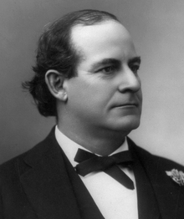
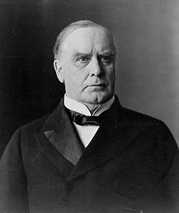
The Republican candidate was William McKinley. McKinley was a people’s person. He was likeable, approachable, and had a knack for being able to reach out to the common man. He came from a humble beginning; born the seventh of nine children in 1843, William McKinley grew up in Ohio. Religion was most important in the McKinley household, followed by education. McKinley himself initially stood out as a star student. McKinley was not necessarily bright, but he was dedicated to his studies and worked diligently in school. He was accepted to Allegheny College in Pennsylvania, but later dropped out after struggling with nervousness. He moved home and worked odd jobs to make ends meet until in 1861 war had broken out, and McKinley decided to enlist on the union side. McKinley gained the attention of many of his superiors while serving during the Civil War, and those connections would serve as a great benefit to him later on. One of these connections was with that of senior officer Rutherford B. Hayes. When Hayes became President in 1877, he ensured McKinley was elected as a U.S. congressman.
McKinley’s opponent was Democrat William Jennings Bryan, a Populist Party member from Nebraska. Because of this, he was seen as an outsider. Bryan was an odd choice for the splintered Democratic ticket. But after speaking at the Democratic National Convention, party members were sure he was the right candidate. Bryan had a great speaking ability; based in his morals, and a stark contrast to the Republicans, Bryan worked for the average American. He attacked McKinley’s defense of the gold standard and fought to back the money supply with silver as well. His most famous line summed up him political and religious views succinctly: “You shall not press down upon the brow of labor this crown of thorns, you shall not crucify mankind upon a cross of gold.”
Prior to the election, an economic panic erupted in 1893. Ignited by the bankruptcy of Philadelphia and Reading Railroad, the banking system nearly imploded. Prices steadily declined for all consumer goods and unemployment skyrocketed to more than 20% in some cities. Banking institutions failed and thousands of businesses went under. Bryan and the Democrats could exploit this in 1896. Still not completely recovered, the United States had serious systematic issues it could address. Bryan could use this panic to place blame on the fat-cat Republicans. Fighting for the average American laborer, Bryan had no interest in protecting big business.
McKinley, however, was in bed with big business. Fighting the silver movement, corporate leaders and big businessmen wholeheartedly supported McKinley. Men like J.P. Morgan, and John D. Rockefeller pumped hundreds of thousands of dollars into his presidential campaign. It is believed that altogether the Republican party was able to have raised $3.5 million during the election season of 1896. Compared to the Democrats, who were thought to have collected $425,000, there should be no surprise as to who won the election.
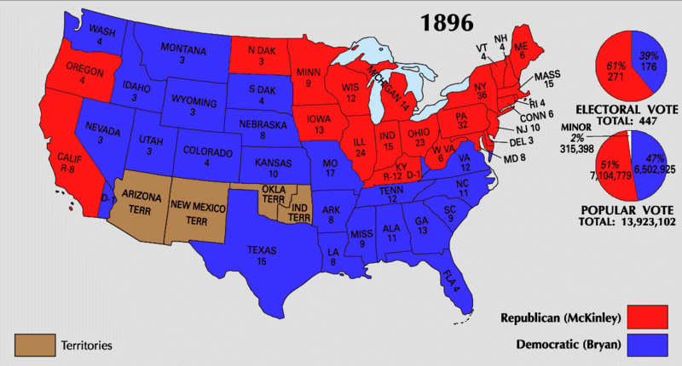
McKinley won 271 electoral votes to Bryan’s 176. Electorally speaking, the race was not close. But the popular vote shows a different story. McKinley won 7.1 million votes while Bryan was not far behind with 6.5 million. The two men ran very different campaigns however. With significantly less money, Bryan traveled the country speaking to crowds and trying to gain support. McKinley, however, stayed at home in Ohio and let crowds come to him. Two very different men, with very different goals and very different styles showed the fracturing that was taking place in American society at the turn of the century. Big business may have been able to spend more and win more, but they could not protect the president from what was to come. The working class would continue to agitate for change. They would strike, they would organize, and in some extreme cases, they would turn to radical ideas like anarchy to attempt to solve their problems.

