American History Name:
Date:
Sources: Angela Barnaby, SUNY, Clinton CC Block:
Capitalism v. Communism
The four basic questions of any economic system are: What will be produced? Who should produce it? How will it be produced? How much should be produced? Differences in economic systems are based on a country’s answer to these basic questions. Two dominant economic systems, capitalism and communism, were at odds with each other through the Cold War (1945-1991). Here, we will examine the two systems.
Capitalism:
Capitalism is an economic system in which a country’s trade and industry are controlled by private owners for profit, rather than by the state. In a capitalist system, the fundamental economic choices are made by individual buyers and sellers interacting in markets. The basic elements of capitalism are private property, freedom of choice, self-interest, and competition. These elements help to answer the four basic economic questions. In a capitalist system, private individuals and groups own the means of production. Businesses are free to produce what they wish and to purchase resources from whomever they choose. Self-interest, or “the invisible hand,” refers to the notion that as individuals pursue their own best interests, they promote the good of society as a whole. This idea was established by Adam Smith, a Scottish philosopher and economist who is considered the “father of capitalism”. Capitalism also depends on competition. Competition allows buyers and sellers who interact to determine prices.
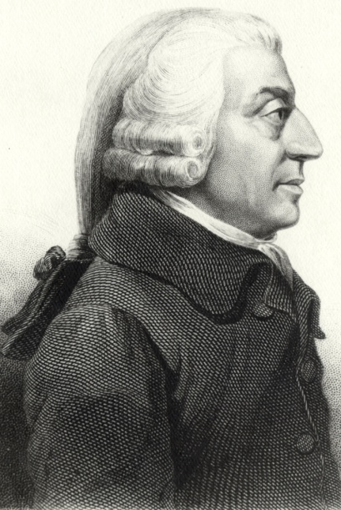
The strengths of capitalism are economic efficiency, economic freedom, and political freedom. In capitalist systems, businesses produce what consumers want, and do so using the least amount of economic resources. In a capitalism system, economic and political power is separate; this means the economy operates with little to no government interference in a capitalist system. Capitalism is also a relatively stable system.
However, capitalism is not a perfect system and has its weaknesses as well. In a capitalist system, wealth that is created is not distributed equally. Similarly, the treatment of the wealthy and the treatment of the poor are unequal. Such imbalances can be disruptive to society and ultimately destabilize the system.

Communism:
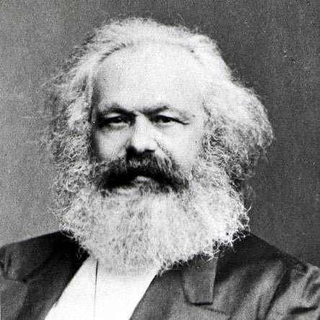
Communism, also referred to as a command economy, is another economic system. In this system, the means of production are publicly owned (meaning by the government), and fundamental economic choices are made by a central authority (usually the government). In command economies, or communist systems, all means of production are owned by the public, decisions are made by a central authority, and that central authority also determines who gets what. In other words, in a command economy, the government is responsible for answering all basic economic questions. The “father of communism” is Karl Marx. Marx was influenced heavily by the revolutions of 1848 in Europe in which people across the continent were fighting for ideas of equality, freedom, and liberty. The theory of communism, as established by Marx, is not the same as Communism that has been put into practice.
The strengths of a command system are: greater equality is offered through the distribution of goods and services, and wealth, communism requires common goals which (ideally) have been agreed upon by those involved, and this cooperation can lead to efficient distribution of goods. It weaknesses lie in the fact that the central authority may not always have the people’s best interest in mind, and it becomes quite difficult to operate in larger populations. Communism also does not account for the human element; it has no way of addressing motivation, greed, work-ethic, and competition. Similarly, because there is a lack of competition, communist systems also struggle to develop new technologies or grow beyond the point at which they began.

http://faculty.clintoncc.suny.edu/faculty/Angela.Barnaby/ECO%20100%20slides%20in%20pdf%20format/Chapter%202%20Lecture%20Notes.pdf

