American History
Mr. Murray
6. Sources: E.H. Mullan Mental Examination of Immigrants: Administration and Line Inspection at Ellis Island (1917); Kenneth C. Davis, Don’t Know Much About History (2003)

The Immigrant Experience
Give me your tired, your poor,
Your huddled masses, yearning to breathe free
The wretched refuse of your teeming shore.
Send these, the homeless, the tempest-tost to me,
I life my lamp beside the golden door!
Emma Lazarus, 1883

It was often said that American streets were paved in gold, and during the global migrations of the 1800s, this myth was believed by many. Immigrants from all over the world had differing reasons for moving to the United States; famine, rising taxes, loss of personal freedoms, political unrest, and the potential for better opportunities were all motivations for immigration to the U.S. The quote above is from the Statue of Liberty, a sight that so many immigrants saw as they reached American shores. But the quote is somewhat misleading; most immigrants coming to the United States during the late nineteenth and early twentieth centuries were middle class citizens in their native countries. They had jobs, provided for their families, and lived a decent lifestyle. But how do their past experiences compare to their experiences in America?
The population of the United States doubled between 1860 and 1920 from 31.5 million to just over 60 million people. Two major ports, Ellis Island on the East coast and Angel Island on the West coast, welcomed immigrants into the country by inspecting and processing them. Other ports in Savannah, New Orleans, and Miami served the same purpose. While most immigrants initially settled in coastal cities, others did find their way inland, settling in the Midwest and Plains regions. What is interesting about immigrant settlements is their patterns. Irish tended to live with or near other Irish; Germans with Germans; Czechs with Czechs, Hungarians, with Hungarians, Italians with Italians.
The immigrant experience was not an easy one. Travel was dangerous and often deadly, and once they arrived, many immigrants were faced with discrimination, abuse, and the fear of starting over. Most immigrants were part of what is known as the “3rd class” or “huddled masses.” They traveled in steerage, which was a large open area beneath the ship’s deck. Traveling conditions were terrible for the 3rd class. Poor ventilation, lack of sanitation, and no privacy were typical accommodations in steerage. The 3rd class was the only class inspected for approval upon their arrival. First and second class passengers were not considered a threat to the American system and were therefore not inspected. It was believed that first and second class passengers would not become institutionalized, or be hospitalized, or become a burden on the state and therefore they were allowed into the country with relatively few restrictions. Third class passengers were different; after docking, immigrants in the third class were segregated for inspection purposes.
Line inspections were conducted by officers of the Public Health Service. Immigrants were formed into four lines in which they went through two separate medical examinations by two medical examiners. The medical examiners were trained to check 6 details with one glance: the scalp, face, neck, hands, gait, and general condition, both physical and mental. If these were hidden by clothing, the clothing would be unbuttoned or removed to ensure no abnormality existed. Hats and caps were always removed to check for any ringworm, lice, and other scalp conditions. Immigrants were also asked questions by the examiners to determine their mental state. If they could answer questions, usually name, destination, nationality, questions of addition and subtraction, they passed. If they could not, they were marked with a chalk “X” on their coat. Other designations were as follows:
B= back F= face H= heart N= neck Sc= scalp
C=conjunctivitis Ft=feet K= hernia P= physical and lungs S= senility
E= eyes G= goiter L= lameness Pg= pregnancy
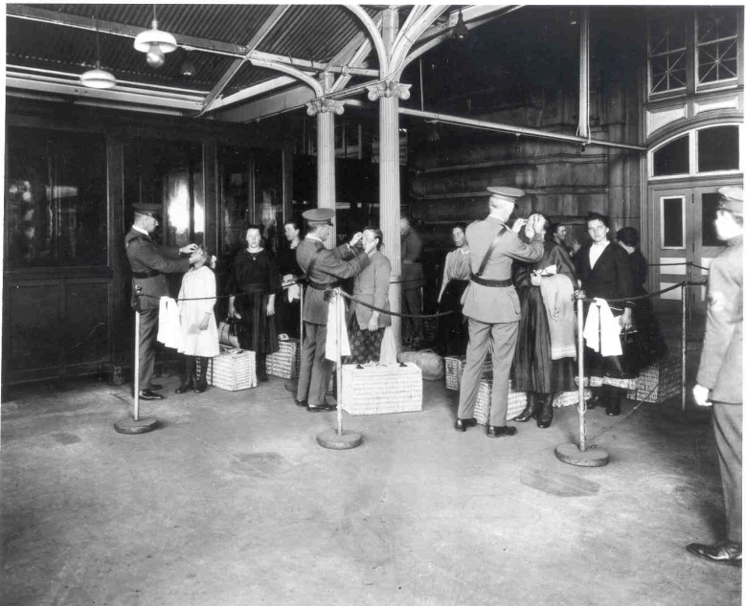
Once an immigrant makes it past the first examiner, he or she continues to the second examiner known as “the eye man.” This examiners job was to check for any oversights the first examiner may have missed as well as carefully examine the eyes. The second examiner usually stood in front of a large window so as to afford him enough light to give a full and complete examination. If an immigrant failed the second examination, he or she would be marked with “Vision” and taken for a third and more complete examination. If an immigrant successfully passed the second examination, he or she would move to the Upper Hall to undergo further examinations. Examinations in the Upper Hall were designed to vet the immigrants; questions were ask to make sure they were not anarchists (anti-government), bigamists (multiple spouses), paupers (poor), criminal, etc.
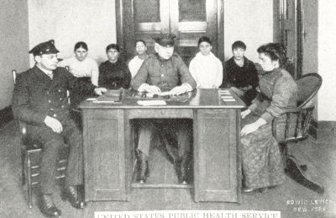
Examiners looked for specific symptoms when trying to diagnose mental fitness of immigrants. Ridiculous symptoms like facial scars, confusion, nail-biting, laughter, and forgetfulness were considered signs of mental deficiency along with more legitimate symptoms like hallucinations and nonresponsive to questions. Considering these immigrants would have been cramped in steerage for a few weeks to a few months, they would obviously exhibit some unusual signs. Many immigrants would have suffered from fatigue, their immune systems would have compromised during the trip, and many faced the difficult battle of a language barrier upon their arrival. This implies that the mental tests given by the examiners were for the most part inaccurate and therefore should have been disregarded.
The “weeding out” process was designed to handle those immigrants who received two “X” marks during the first two examinations. After receiving the second “X” immigrants were taken immediately to the mental room. Here, more mental tests were run. Immigrants were questioned further about addition, subtraction, multiplication, and spatial reasoning. If they failed, immigrants were held overnight. Any immigrant who received a “hold card” was then subjected to more tests to further weed out the deficient from the competent. Those determined to be deficient and “feeble-minded” were usually deported and sent back to their native country.
If an immigrant could make it through all of the initial tests and examinations, they were free to begin their new lives in America. However, they would continue to face trials and tribulations in their journeys to become “Americans.”

