American History
Mrs. Barnes
Sources: America (2003)
The American Home Front
Waging war required many sacrifices at home. Despite the efforts of the preparedness movement, the American economy was not ready to meet the demands of modern warfare. In this era, war required huge amounts of money and personnel. As President Wilson explained, now “there are no armies…; there are entire nations armed.”
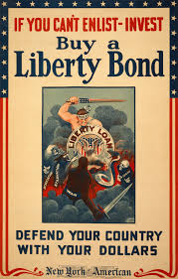
The government launched a vigorous campaign to raise money from the American people. It started offering Liberty Bonds, special war bonds sold to support the Allied cause. Like all bonds, they could later be redeemed for the original value of the bonds plus interest. Secretary of the Treasury William Gibbs McAdoo had the idea for Liberty Bonds. By selling war bonds to enthusiastic Americans, McAdoo raised more than $20 billion. This allowed the United States to loan more than $10 billion to the Allies during and just after the war. Responding to the slogan “Every Scout to Save a Soldier,” Boy Scouts and Girls Scouts set up booths on street corners and sold bonds.
The government also called on industry to convert to the production of war goods. In 1918 Wilson won authority to set up a huge bureaucracy to manage this process. Business leaders flocked to Washington to take up posts in thousands of new agencies. A War Industries Board, headed by financier Bernard Baruch, oversaw the nation’s war-related production. The board had far-reaching powers. It doled out raw materials, told manufacturers what and how much to produce, and even fixed prices. A War Trade Board licensed foreign trade and punished firms suspected of dealing with the enemy. A National War Labor Board, set up in April 1918 under former President Taft, worked to settle any labor disputes that might hinder the war effort. Labor leader Samuel Gompers promised to limit labor strife in war production industries. A separate War Labor Policies Board set standard wages, hours, and working conditions in the war industries. Labor unions won limited rights to organize and bargain collectively.
In August 1917 Congress passed the Lever Food and Fuel Control Act. This act gave the President the power to manage the production and distribution of foods and fuels vital to the war effort. Using the slogan “Food will win the war,” the government began regulating food consumption. Under the leadership of engineer and future President Herbert Hoover, the Food Administration worked to increase agricultural output and reduce waste. Hoover had the power to impose price controls, a system of pricing determined by the government, on food. He also could have begun a system rationing, or distributing goods to consumers in a fixed amount. But he opposed both these approaches. Hoover hoped instead that voluntary restraint and increased efficiency would accomplish the Food Administration’s goals.
Women played a key role in Hoover’s program. Writing to women in August 1917, he preached a “Gospel of the Clean Plate.” He appealed: “Stop, before throwing any food away, and ask ‘Can it be used?’…Stop catering to different appetites. No second helpings. Stop all eating between meals…One meatless day a week. One wheatless meal a day...No butter in cooking: use substitutes. The American woman and the American home can bring to a successful end the greatest national task that has ever been accepted by the American people.” Eager to take part in the war effort, women across the country responded to this patriotic challenge. The Lever Food and Fuel Control Act also created an agency called the Fuel Administration. It sponsored gasless days to save fuel. This agency also began the practice of daylight savings time—turning clocks ahead one hour for the summer. This new policy increased the number of daylight hours available for activities. In this way, daylight saving time lessened the need for artificial light, which lowered fuel consumption.
Thanks to the war, some hopes of progressive-era reformers had come to pass. Government now regulated American economic life to an extent most progressives had never dreamed possible. But when private lives were altered during these changes, some progressives began to wonder if reforms had gone too far. And, converse to the progressive goal, the influence of business leaders grew and the government relaxed its pursuits of antitrust suits, and corporate profits tripled.
American patriotism and war fever made military styles and activities more acceptable at home. Scouting programs for boys and girls, involving military-style uniforms, marching, and patriotic excesses, grew in popularity. Military drill became part of many school programs. By the summer of 1918, all able-bodied males in colleges and universities became army privates, subject to military discipline. Americans turned away from military styles and activities after the war. But the other social changes had more lasting effects. The war cut off the flow of immigrants from Europe, and the armed forces took many young men out of the labor pool. Businesses, especially war-related industries, suddenly needed workers. These wartime conditions propelled some people into higher paid jobs. Factories that used to discriminate against African Americans and Mexican Americans now actively recruited them.
The African Americans who left the South to work in northern factories added to a steady stream of migrants that had started in the late 1800s. The stream turned into a flood during the warm when some 500,000 African Americans joined what came to be called the Great Migration. Wage-earning women, too, benefited from the diminished work force. Some women found jobs on farms, thanks to organizations such as the Women’s Land Army. Others moved into jobs previously closed to them, such as telegraph messenger, elevator operator, and letter carrier. A few earned management positions. As a result of the war, about 400,000 women joined the industrial work force for the first time. In 1917 a speaker for the Women’s Trade Union League proclaimed, “At last, after centuries of disabilities and discrimination, women are coming into the labor and festival of life on equal terms with men.” Such pronouncements, while premature, celebrated what seemed like a major social change.
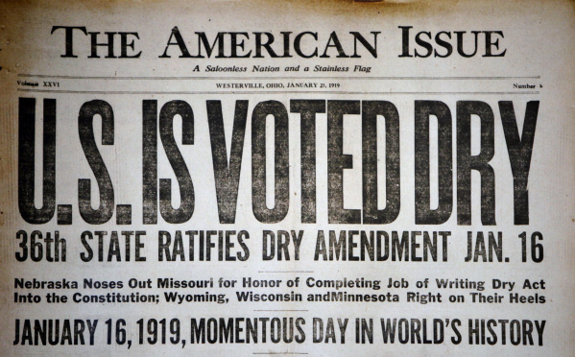
In 1917 the temperance movement was almost a century old. The temperance movement was an organized campaign to eliminate alcohol consumption. In 1917, Congress proposed the Eighteenth Amendment to the Constitution, which made it illegal to manufacture, sell, or transport alcoholic beverages in the United States. Members of Congress backed the Eighteenth Amendment in part to show patriotism during wartime. The production of alcohol used a lot of grain which was now needed to make the bread to feed people at home and overseas. The states ratified the Prohibition Amendment in 1919.

