American History Name:
Date:
Sources: Block:
Kenneth C. Davis, Don’t Know Much About History (2003); Britannica; Scholastic; Los Alamos Historical Society

The Manhattan Project
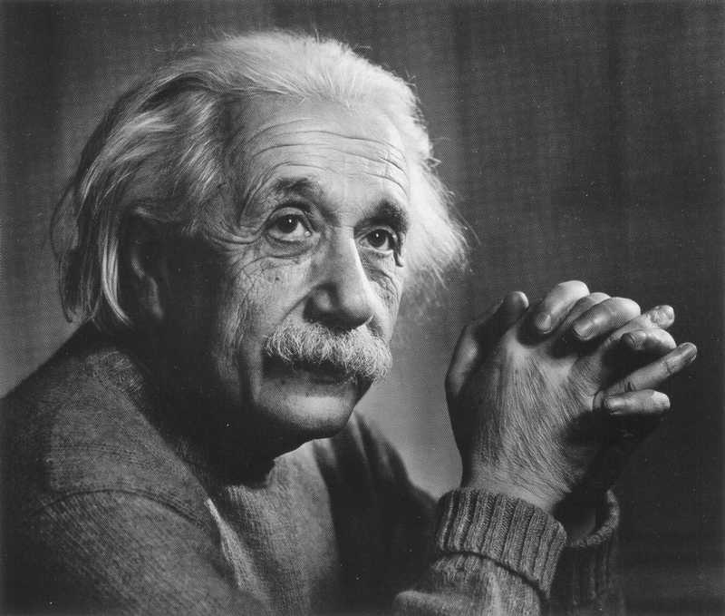
In 1939, Albert Einstein wrote a letter to U.S. President Franklin Delano Roosevelt. Hand-delivered to the President by financier adviser Alexander Sachs, the letter detailed important scientific information that would change the course of war forever. In the letter, Einstein discussed the implications of a nuclear chain reaction and the powerful bombs that could be constructed. He believed that uranium could be enriched and potentially turned into an energy source. He said, “A single bomb of this type, carried by boat and exploded in a port, might very well destroy the whole port, together with some of the surrounding territory.” Upon receiving the letter, President Roosevelt ordered a plan to develop the atomic bomb, which became known as the Manhattan Project.
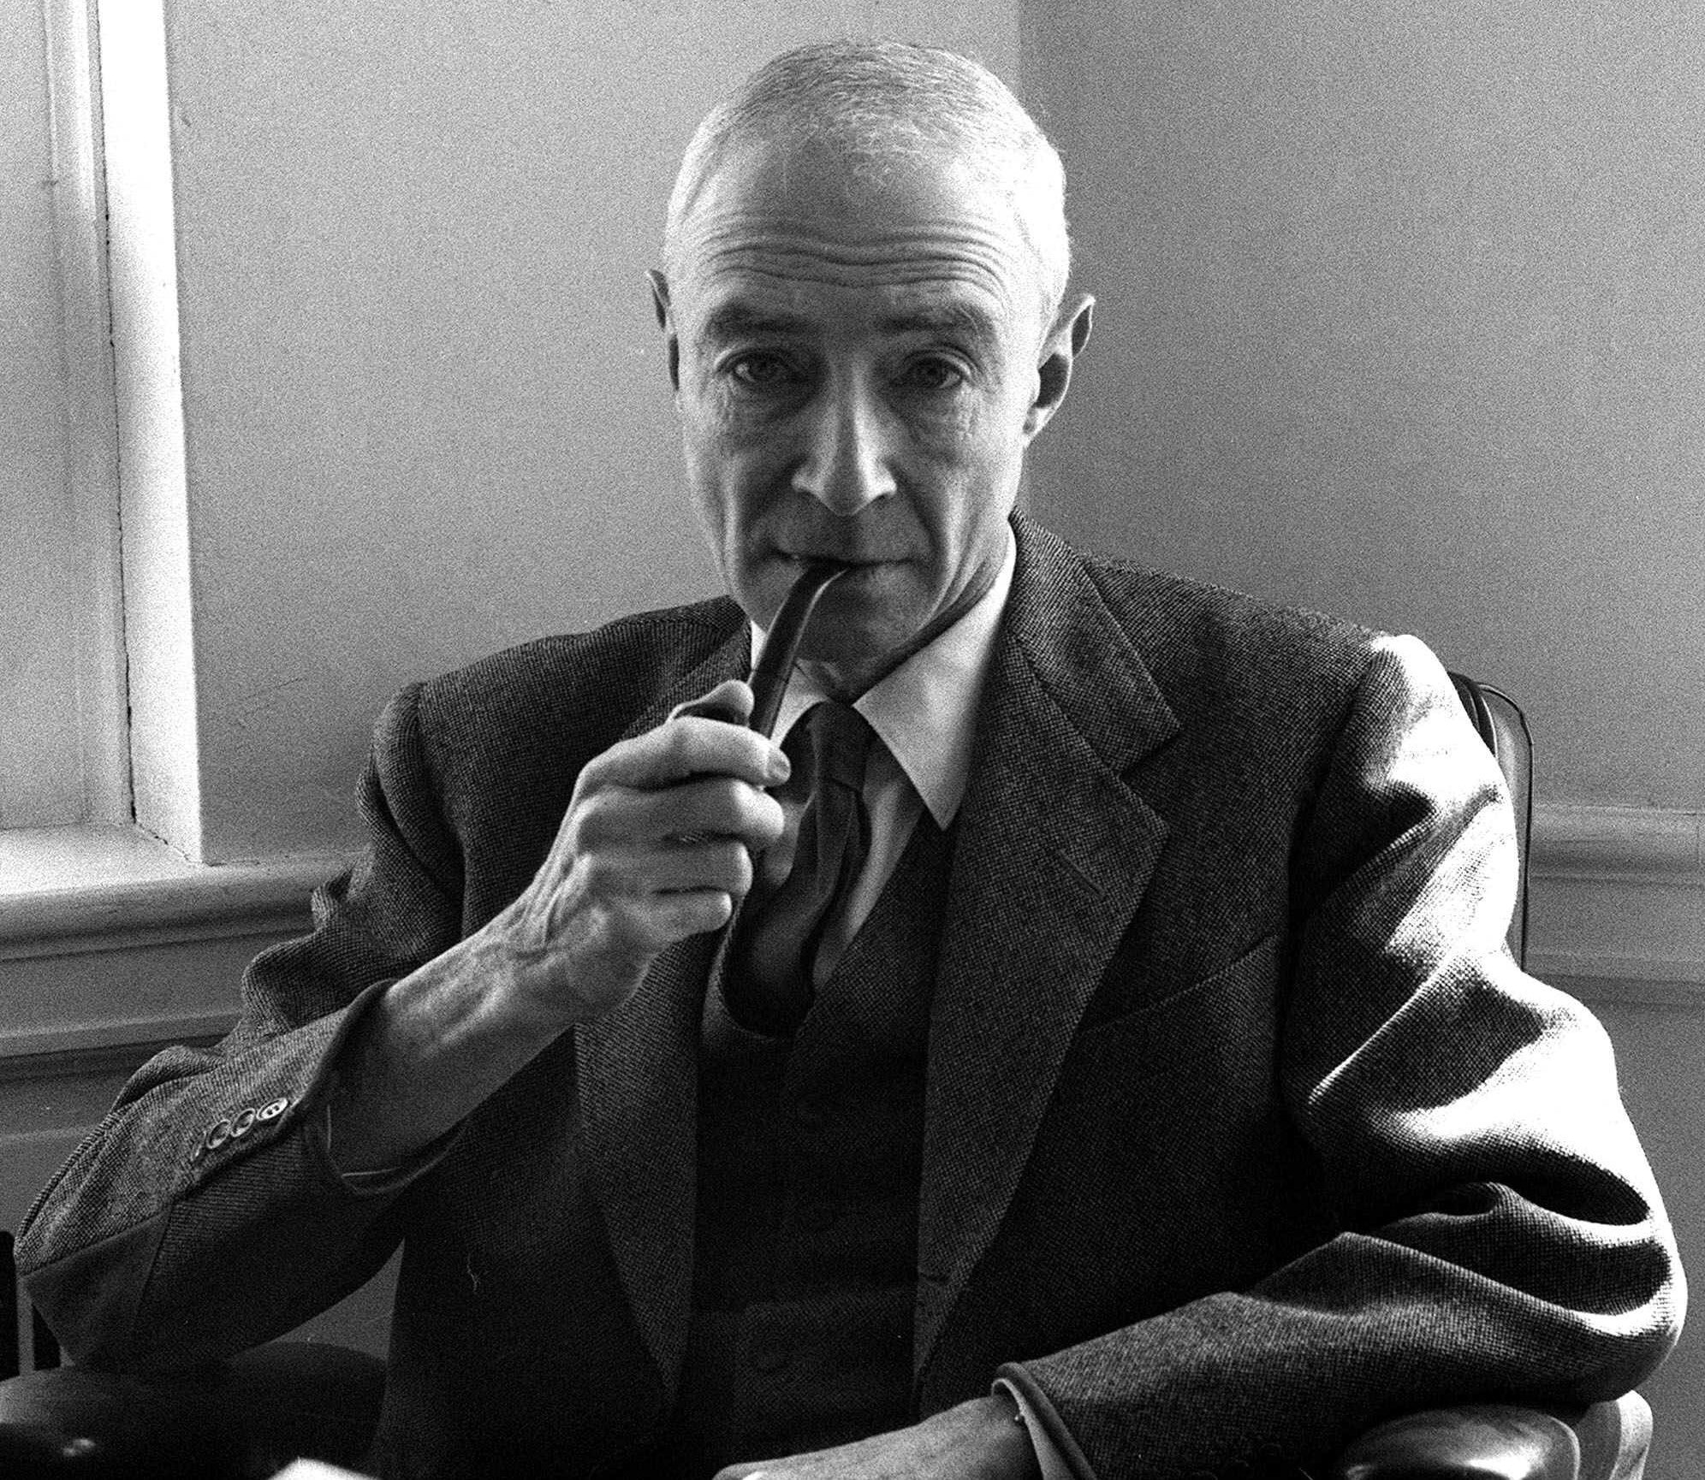
In the previous years, America had become a refuge for many escaping fascist regimes. Some of those refugees happened to be scientists, some even at the top of their respective fields. In 1939, these scientists organized a project to exploit the newly recognized fission (fission is the action of dividing or splitting something into two or more parts) process for military purposes. It was well-known that by 1940 German scientists were working on a similar project. The Manhattan Project was named for the Manhattan Engineer District of the U.S. Army Corps of Engineers, since most of the early research was done in New York City. From 1938 to 1942, the scientific work regarding fission had mostly been theoretical (referring to theory of the subject rather than the practical application). In 1942, the project was placed under the direction of the United States Army and General Leslie Groves. Dr. J. Robert Oppenheimer was chosen to lead the research of the Manhattan Project.
J. Robert Oppenheimer
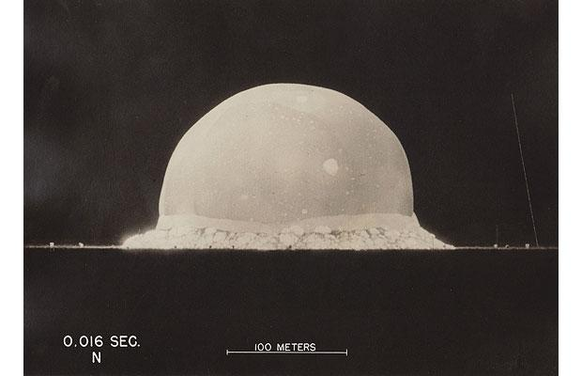
The Manhattan Project was known only to a handful of men, and Vice President Truman was not among them. Einstein’s letter to FDR was so persuasive that FDR ordered the project begin with $2 billion in hopes of developing the world’s first atomic weapon. Working at Los Alamos, New Mexico, under the direction of J. Robert Oppenheimer, atomic scientists, many of them refugees from Hitler’s Europe, thought they were racing against Germans developing a “Nazi bomb.” That effort was later proved to be far short of success. The Pajarito Plateau near Los Alamos, New Mexico, became the site location for research. Physicists, chemists, metallurgists, explosive experts and military personnel converged on the isolated plateau. Meanwhile, the Army was charged with supporting the work, building buildings, keeping the commissary supplied, and guarding the top secret work.

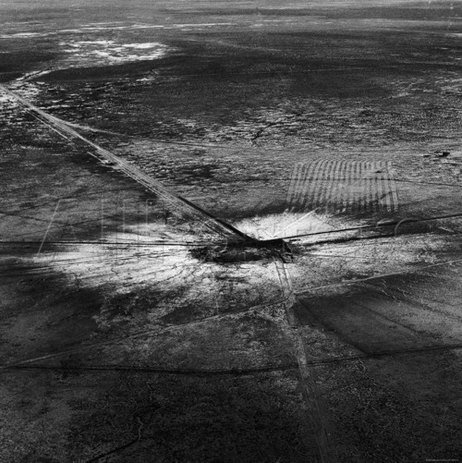
The first atomic bomb was exploded at Alamogordo, New Mexico, on July 16, 1845. By this time, Harry Truman was President of the United States, following the death of FDR, and had been made aware of the project’s existence. Truman was alerted to the success of the test in New Mexico at a meeting with Churchill and Stalin at Potsdam, a city in defeated Germany. With the successful test, use of the atomic bomb was now a reality.
Bomb Crater; Trinity Site, New Mexico

