American History Name:
Mr. Murray Date:
Block:
The Rise of Dictators
In September 1936, German dictator Adolf Hitler called hundreds of thousands of his followers to a week-long rally in the German city of Nuremberg. Included with political meetings and parades was a nighttime ceremony: the Oath under the Cathedral of Light. Amid waving red banners and circling searchlights, Hitler led the audience of 180,000 in a “holy oath” to Germany.
Grand spectacles like the Nuremberg Party Rally were essential to Hitler’s totalitarian rule. A totalitarian government exerts total control over a nation. It dominates every aspect of life, using terror to suppress individual rights and silence all forms of opposition. The pride and unity of the Nuremberg rally hid the fact that people who disagreed with Hitler were silenced, beaten, or killed. Hitler’s power rested on the destruction of the individual.
In a similar fashion to Hitler, although not exactly the same, Italy’s Benito Mussolini governed by a philosophy called fascism. Fascism emphasized the importance of the nation or an ethnic group and the supreme authority of the leader. In the Soviet Union, Joseph Stalin based his totalitarian government on a vicious form of communism. Like fascism, communism relies upon a strong, dictatorial government that does not respect individual rights and freedoms. Historically, however, Communists and Fascists have been fierce enemies.
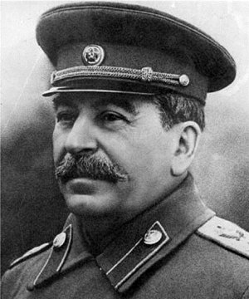
While Lenin led the Soviet Union, the worldwide Communist revolution he sought never took place. Even in his own country, economic failure threatened Communist control of the government. Lenin eased up on the drive to convert all property to public ownership. His New Economic Policy (NEP) allowed some private business to continue. Stalin took over after Lenin’s death in 1924. Stalin decided to abandon the NEW and take “one great leap forward” to communism. He launched the first of a series of five-year plans to modernize agriculture and build new industries from the ground up.
To modernize agriculture, Stalin encouraged Soviet farmers to combine their small family farms into huge collective farms owned and run by the state. Facing widespread resistance, Stalin began forcing peasants off their land in the late 1920s. The state takeover of farming was completed within a few years, but with terrible consequences. In the Ukraine and other agricultural regions, Stalin punished resistant farmers by confiscating much or all of the food they produced. Millions of people died from starvation, and millions more fled to the cities. Stalin also sent approximately 5 million peasants to labor camps in Siberia and northern Russia. In addition to the human cost, the collectivization campaign caused agricultural production to fall dramatically. Food shortages forced Stalin to introduce rationing throughout the country.
Stalin pursued rapid industrialization with more success. He assigned millions of laborers from rural areas to build and run new industrial centers where iron, steel, oil, and coal were produced. Because Stalin poured money and labor into these basic industries rather than housing, clothing, and consumer goods, the Soviet people endured severe shortages of essential products, and their standard of living fell sharply.
During the economic upheaval, Stalin completed his political domination of the Soviet Union through a series of purges. In political terms, a purge is the process of removing enemies and undesirable individuals from power. Stalin “purified” the Communist Party by getting rid of his opponents and anyone else he believed to be a threat to his power or to his ideas. The Great Purge began in 1934 with a series of “show trials,” in which the only possible verdict was “guilty.” Stalin’s reign of terror did not stop there, however. He and his followers purged local party offices, collective farms, the secret police, and the army of anyone whom he considered a threat. By 1939, his agents had arrested more than 7 million people from all levels of society. A million were executed, and millions more ended up in forced labor camps. Nearly all of the people were innocent victims of Stalin’s paranoia. But the purges successfully eliminated all threats to Stalin’s power, real or imagined.
As in the Soviet Union, Italy’s totalitarian government arose from the failures of World War I. Benito Mussolini had fought and been wounded in the war. He believed strongly that the Versailles Treaty should have granted Italy more territory. A talented speaker, Mussolini began to attract followers, including other dissatisfied war veterans, opponents of the monarchy, Socialists, and anarchists. In 1919, Mussolini and his supporters formed the revolutionary Fascist Party.
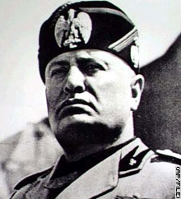
Calling himself Il Duce “the leader,” Mussolini organized Fascist groups throughout Italy. He relied on gangs of Fascist thugs, called Blackshirts because of the way they dressed, to terrorize and bring under control those who opposed him. By 1922, Mussolini had become such a powerful figure that when he threatened to march on Rome, the king panicked and appointed him prime minister.
Strikes and riots had plagued Italy since World War I. Mussolini and the Fascists vowed to end Italy’s economic problems. In the name of efficiency and order, they suspended elections, outlawed all other political parties, and established a dictatorship. Italy’s ailing economy improved under Il Duce’s firm command. Other European nations noted his success with the Italian economy and applauded him as a miracle worker. They would soon choke on their words of praise, however, for Mussolini had dreams of forging a new Roman Empire. A Fascist slogan summed up Mussolini’s expansionist goals: “The Country is Nothing Without Conquest.”
In October 1935, Mussolini put those words into practice by invading the independent African kingdom of Ethiopia. The Ethiopians resisted fiercely, but the large Italian army, using warplanes and poison gas, overpowered the Ethiopian forces. By May 1936, Ethiopia’s emperor had fled to England and the capital, Addis Ababa, was in Italian hands.
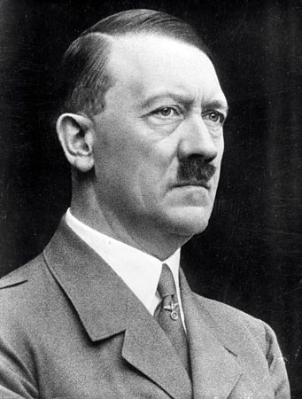
While Mussolini was gaining control in Italy, a discontented Austrian painter was rising to prominence in Germany. Like Mussolini, Adolf Hitler had been wounded while serving in World War I. He, too, felt enraged by the terms of the peace settlement, which stripped Germany of land and colonies and imposed a huge burden of debt to pay for the damage done to France, Belgium, and Britain. He especially hated the war-guilt clause—the section of the Versailles Treaty that forced Germany to accept the blame for starting the war.
In 1919, Hitler joined a small political group that became the National Socialist German Worker’s Party, or later the Nazi Party. The philosophy and policies of this party came to be known as Nazism. Nazism was a form of fascism shaped by Hitler’s fanatical ideas about German nationalism and racial superiority. Hitler’s powerful public-speaking abilities quickly made him a leader of his party. The Nazis held mass meetings at which Hitler spoke passionately against Germany’s national humiliation. In November 1923, with some 3,000 followers, Hitler tried to overthrow the German government. Authorities easily crushed the uprising. Although a German court sentenced Hitler to five years in prison, he only spent nine months in confinement. While in prison, Hitler wrote Mein Kampf (“My Struggle”), which outlined his philosophy, his views of Germany’s problems, and his plans for the nation.
Hitler’s promises eventually won his a large following. In the 1932 elections, the Nazi Party became the largest group in the Reichstag (Germany’s equivalent to our Congress, or legislative branch). In January 1933, Hitler was appointed Chancellor by President Hindenburg, a war general and hero, placing Hitler at the head of the German government. Hitler soon suspended civil liberties such as freedom of speech and freedom of the press. Thousands of Nazi thugs, known as Brownshirts, waged a violent campaign that silenced those opposed to Hitler’s policies. In August 1934, President Hindenburg died, which ultimately made Hitler both Chancellor and President, giving him total power. He gave himself the title of Der Führer, or “the leader.”

