American History Name:
Mrs. Barnes Date:
Sources: America (2003) Block:
Society in the 1920s
The decade of the 1920s stands out as a time of rapid change in American society. Much of the change had its roots in the previous century. In the late 1800s, industrialization and immigration began transforming the United States into an urban nation. Farm families streamed into the cities. Along with masses of immigrants, the new arrivals helped form a more complex urban culture. The Great War accelerated those changes. Millions of young people had marched off to war full of enthusiasm. Many returned bearing the scars of that war: shell shock, permanent injury, and the effects of poison gas. Many also came back disillusioned, a condition they shared with others who had stayed home during the war. Together, they questioned the ideas and attitudes that had led to the war. Their challenge of traditional values helped ignite a revolution in manners and morals.
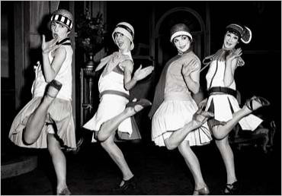
Women: The flapper symbolized this revolution. The term described a new typed of young woman: rebellious, energetic, fun-loving, and bold. Many older Americans held more traditional views of how young women were supposed to behave in public. They disapproved not only of the flappers’ display of free manners but also of the behavior of the young men who flocked around them. Women stood at the center of social change in the 1920s. Both single and married women had been in the work force for a long time. During the war, their numbers rose as they moved into better, higher-paying jobs. After the 19th Amendment was adopted in 1920, all American women could vote. These experiences made them eager for still greater equality with men. Without intending to, the rebellious flapper brought all women closer to that goal.
The flapper represented only a small number of American women, yet her image had a wide impact on fashion and on behavior. Stylish young women began wearing dresses shorter than their mothers did, to the dismay of some guardians of decency. In 1920, hemlines had risen to just nine inches above the ground. By 1927, they would rise to knee-length or even higher. Between 1913 and 1928, the average amount of fabric used to make a woman’s outfit shrank from 19.5 yards to just 7 yards. Women also began to break with past by changing their hair style. While most of their mothers had grown their hair long and then pinned it up, young women bobbed, or cut short, their hair. Instead of wide-brimmed hats, they wore the close-fitting “cloche” whose bell shape accentuated their new hairstyles. They began wearing heavy makeup, a practice formerly associated with actresses or prostitutes. Manners changed as well. Women began to drink alcohol and smoked cigarettes in public. In fact, between 1918 and 1928, the number of cigarettes produced in the U.S. more than doubled.
Alcohol: Liquor, beer, and wine could no longer be manufactured, sold, or transported in the United States. American who chose to defy the Volstead Act needed to find a private source of alcoholic beverages. For this they turned to a new type of criminal: the bootlegger.
In the old days, bootleggers merely had been drinkers who hid flasks of liquor in the leg of their boots. Now the term was used to describe suppliers of illegal alcohol. Some bootleggers operated stills—devices used to produce alcohol from corn, grain, potatoes, and other fruit and vegetable sources. Others smuggled liquor overland from Canada or by ship from the Caribbean. A smuggler’s ship might anchor far off the coast, where its illegal cargo would be loaded onto speedboats fast enough to outrace the Coast Guard cutters. The boats would then head to secluded harbors where trucks were waiting to carry the liquor to warehouses. From there, it would be transported to retail outlets. Those outlets included restaurants, nightclubs, and speakeasies.
Speakeasies were bars that operated illegally. These bars flourished in the cities. One observer estimated that there were 700 speakeasies and 4,000 bootleggers in Washington D.C., a city with only 300 licensed saloons before Prohibition. A customer could not just stroll into a speakeasy. A heavy gate usually blocked the entrance, and the customer had to show a membership card or be recognized by a guard. A French diplomat observed:
“Some speakeasies are disguised behind florists’ shops, or behind undertakers’ coffins. I know one, right in Broadway, which in entered through an imitation telephone box; it has excellent beer…”
Supplying illegal liquor was a complex operation, involving manufacture, transportation, storage, and sales. This complexity, and bootlegging’s huge potential for profit, helped lead to the development of organized crime. At first, local gangers operated independently, competing to supply liquor. Then some of them found that by joining forces they could create an organization large and efficient enough to handle the entire bootlegging operation. When these organizations tried to expand their territory, they clashed with other gangs. As rival groups fought for control with machine guns and sawed-off shotguns, gang wars and murder became commonplace. The streets of American cities became a battleground.
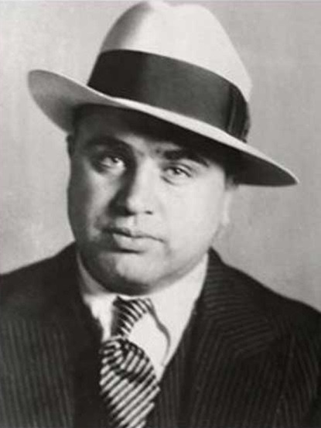
Successful bootlegging organizations often moves into other illegal activities, including gambling, prostitution, and a highly profitable business called racketeering. In one kind of “racket,” gangsters bribed police or other government officials to ignore their illegal operations. In another, gangsters forced local businesses to pay a fee for “protection.” Those who refused to pay might be gunned down or have their businesses ransacked, or even worse, blown up. Terrified citizens went along with the gangsters’ demands.
The most notorious of the gangster organizations operated in Chicago. There, bootlegging had added immense wealth to an already successful gambling, prostitution, and racketeering business that reached into nearly every neighborhood, police station, and government office. In 1925, a young gangster murdered his way to the top of Chicago’s organized crime network. He was Al Capone, nicknamed “Scarface.” Capone was a ruthless criminal with a talent for avoiding jail. With so much money at his disposal ($60 million a year from bootlegging along), Capone easily bought the cooperation of police and city officials. Politicians, even judges, took orders from him.
The government fought back with improved law enforcement. The Bureau of Investigation (later named the Federal Bureau of Investigation, or FBI) headed by J. Edgar Hoover, became a dedicated, independent force against organized crime during the 1920s. Still, Capone managed for years to slip out of any charges brought against him. Finally, in 1931, a federal court convicted him of income-tax evasion and sent him to prison. Bootlegging remained a problem, however, until Prohibition ended in 1933.

