American History Name:
Date:
Source: Kenneth C. Davis Don’t Know Much About History (2003) Block:
Civil Disobedience—Bus Boycotts
The Brown v. Board of Education case was a landmark Supreme Court decision. A landmark decision is one that establishes new precedents which establish significant new laws, principles, or concepts. In this case, the Warren Court (led by Chief Justice Earl Warren) in 1954 decided that the long-standing principle of “separate but equal” was unconstitutional in relation to public education and that there was no room for segregation in public schools. This decision required states across the nation to desegregate school districts, a process that would prove to be long and painful, and in some cases, still an issue today.
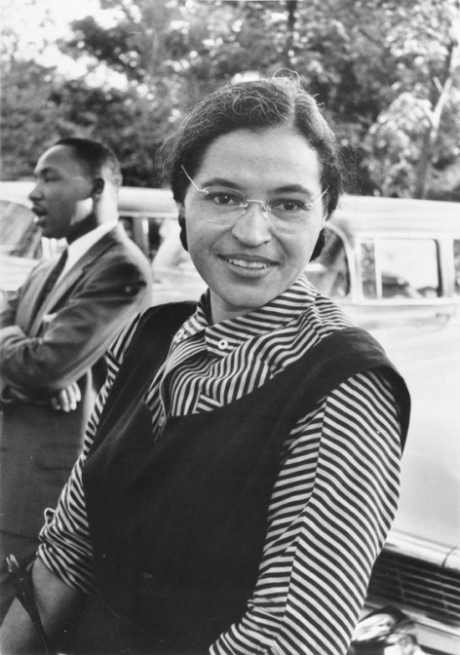
But segregation and unequal treatment of minorities was being challenged in other ways as well. In 1955, in Montgomery, Alabama, a forty-three year old seamstress who worked in a downtown Montgomery department store, Rosa Parks was on her way home from work on a December day. Loaded down by bags filled with her Christmas shopping, Rosa Parks boarded a city bus and moved to the back—legally, traditionally, and it seemed eternally—the Negro section. Finding no seats there, she took one toward the middle of the bus. When the driver picked up more white passengers, he called out, “Niggers move back,” an order to vacate the white seats even if it meant standing. Mrs. Parks refused. Active in the local chapter of the NAACP, Rosa Parks had already decided that she would make a figurative stand if asked to give up her seat.
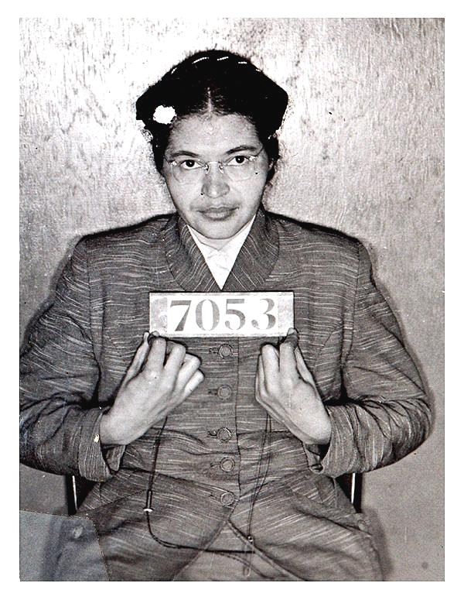
Unwilling to leave that seat, Rosa Parks was arrested for violating Montgomery’s transportation laws. Mrs. Parks was ordered to court the following Monday. But over the weekend, the blacks of Montgomery found a movement and a leader to believe in. Meeting to protest Mrs. Parks’s arrest and the reason for it, the black community of Montgomery selected the twenty-seven-year old pastor of Mrs. Park’s church, the Dexter Avenue Baptist Church, as its leader. Calling for a peaceful form of resistance, the young minister urged his people to boycott the buses of Montgomery. His name was Martin Luther King Jr. (1929-1968). In a short time, the bus boycott and the movement it inspired in Montgomery would raise him to world fame and make him one of the nation’s most admired and reviled (hated) men.
Montgomery’s Transportation Laws (in regards to busing: Title 48, Section 301, Subsections 31a, 31b, and 31c, are as follows):
Section 301 (31a): Separate waiting rooms or space, and separate ticket windows but they must be equal; equal but separate accommodations on each vehicle.
Section 301 (31b): Operators of passenger stations and carriers authorized to provide separate but equal accommodations.
Section 301 (31c): Unlawful to willfully refuse or fail to comply with any reasonable rule, regulation or directive; penalty is $500 maximum…
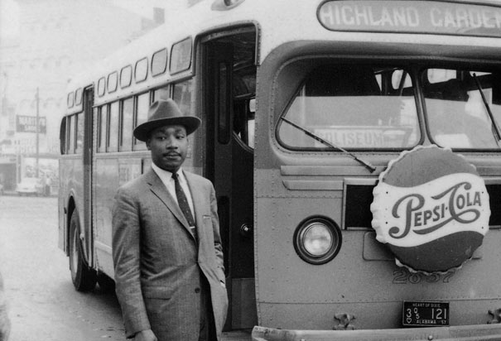
King was born in Atlanta, the son of one of that city’s prominent black ministers and grandson of the man who had organized a protest that created Atlanta’s first black high school, named for Booker T. Washington, which King himself attended. He went on to Atlanta’s Morehead College, studied theology and philosophy at Crozier Theological Seminary and the University of Pennsylvania, and had completed his Ph.D. in systematic theology from Boston University in 1955 when he took the call at Dexter Avenue. Buttressed by the twin principles of nonviolence and civil disobedience inspired by Henry David Thoreau and India’s Mahatma Gandhi, King planned to shape a civil rights movement using the fundamental moral teachings of Christianity—love, forgiveness, humility, faith, hope, community—as its bedrock. The Montgomery boycott, begun on December 5, 1955, presented him with the first opportunity to try this approach.
For more than a year, the boycott was hugely effective. Angry because they couldn’t make these Negroes ride the buses, the whites of Montgomery looked for other ways to retaliate. Mrs. Parks was rearrested for failing to pay her fine. King was arrested, first on a drunk-driving charge and later for conspiring to organize an illegal boycott. Insurance companies canceled the auto insurance on cars being used to circumvent the buses. When peaceful means failed, black homes were firebombed. A shotgun blast broke the windows of King’s home. And of course the KKK appeared on the scene, to march through the streets of Montgomery.
The case wound its way back to Washington, where the Supreme Court, now armed with the Brown precedent, was beginning to roll back “separate but equal” statutes in all areas of life. The Court ordered an end to Montgomery’s bus segregation in November 1956, and on the morning of December 21, 1956, the blacks of Montgomery went back to the buses. They had won a battle, but the war was just beginning. The peaceful boycott movement gathered momentum and was duplicated throughout the South. For the next ten years these peaceful protests led the civil rights movement until the painfully slow process finally boiled over in the urban racial violence of the mid-1960s.
Despite the success of the protest, the international notoriety Martin Luther king had gained created some dissension among the ranks. Mrs. Parks, who lost her job as a seamstress, later took a job at the Hampton Institute in Virginia, and remained a living symbol of the civil rights movement.
In 1857, King moved to Atlanta and organized the Southern Christian Leadership Conference (SCLC). Later that year he led the first civil rights march to Washington in a prayer pilgrimage. This time 50,000 blacks joined him. In the future he would return with hundreds of thousands.

- How did the Brown v. Board ruling affect other areas of life (other than education)?

- What consequences did blacks face after deciding to protest the injustices of segregation?

- In 1955, blacks made up 70% of the riders who used the Montgomery bus system, yet a municipal (city) law precluded them from sitting wherever they wanted. Based on this statistic, what effect would the bus boycott have on the busing system?

