American History Name:
Date:
Sources: America (2003); “World War II: The Pacific Islands,” The Atlantic (2011) Block:

Island Hopping
After the Japanese attack at Pearl Harbor on December 7, 1941, the U.S. was at war with Japan. Japan had spent the last five decades expanding their empire and seizing territory for various purposes. When the U.S. placed trade embargoes and other restrictions on Japan in an attempt to halt their expansion, Japan retaliated by attacking the U.S. Naval base at Pearl Harbor. After a period of modernization, beginning mid-nineteenth century, Japan became a force to be reckoned with. Winning battles against major powers like Russia proved they were capable of fighting, and winning, on a world stage. If the U.S. was going to defeat Japan, they would need a superior military strategy.
The strategy adopted by the U.S. in the Pacific Theater is known as island hopping. Island hopping was a military strategy of selectively attacking specific enemy-held islands and bypassing others. By capturing only a few crucial islands, the United States effectively cut off the bypassed islands from supplies and reinforcements and rendered those islands useless to the Japanese. This strategy also allowed the Americans to move more quickly toward their ultimate goal—the Japanese mainland.
Island hopping, also known as “leapfrogging,” was a strategy adopted at the end of 1942 by naval Admiral Chester M. Nimitz. Rather than attacking Japan’s Imperial Navy in force, the goal was to capture and control strategic islands along a path toward the Japanese home islands, bringing U.S. bombers within range and preparing for a possible invasion. American forces would capture an island and then quickly construct landing strips for planes and small military bases in preparation to invade the next island. Japanese fought the island landings fiercely, killed many Allied soldiers and sometimes making desperate, last-ditch suicidal attacks. At sea, Japanese submarine, bomber, and kamikaze attacks took a heavy toll on the U.S. fleet, but Japan was unable to halt the island-by-island advance. By early 1945, leapfrogging U.S. forces had advanced as far as Iwo Jima and Okinawa, within 340 miles of mainland Japan.
In 1943 and 1944, the Allies pushed north from Australia and west across the Central Pacific. Forces under General MacArthur and Admiral William Halsey leapfrogged through the Solomon Islands while Admiral Nimitz led a similar island-hopping campaign in the Gilbert Islands. After seizing the island of Tarawa, Nimitz used it to launch bombing raids on Japanese bases in the Marshall Islands. By February 1944, these attacks had crippled Japanese air power, allowing Nimitz’s forces to seize a group of islands in the northwest. From the Marshall Islands, Nimitz captured parts of the Mariana Islands in June. For the first time, Japan was within reach of long-range American bombers. By the end of 1944, B-29 Superfortresses were dropping tons of explosives on Japanese cities.
As American forces pushed toward Japan in the summer of 1944, military planners decided to bypass the Philippine Islands. MacArthur vigorously opposed this strategy, claiming that the United States had an obligation to free the Filipino people. The general’s arguments persuaded Roosevelt who reversed the decision.
In mid-October, some 160,000 American troops invaded the Philippine island of Leyte. After the beach was secure, General MacArthur dramatically waded ashore from a landing craft. News cameras recorded the historic event as MacArthur proclaimed, “People of the Philippines, I have returned.”
While American troops fought their way inland, the greatest naval battle in world history developed off the coast. More than 280 warships took part in the three-day Battle of Leyte Gulf. The Japanese high command directed nearly every warship still afloat to attack the United States Navy. This was the first battle in which Japanese kamikazes, or suicide planes, were used. Kamikaze pilots loaded their aircraft with bombs and then deliberately crashed them into enemy ships to inflict maximum damage. Despite this tactic, the American force virtually destroyed the Japanese navy and emerged victorious.
Japanese land forces in the Philippines continued to resist, however. American troops needed two months to liberate Leyte. Some 80,000 Japanese defenders were killed and fewer than 1,000 Japanese surrendered. The battle for the Philippines’ capital city of Manila, on the island of Luzon, was equally hard fought. Fighting left most of Manila in ruins and some 100,000 Filipino civilians dead. Not until June 1945 did the Allies control the Philippines.
Phases of Island Hopping:
- From December 7, 1941 until June 1942, the Japanese successfully attacked the Pacific Fleet’s base at Pearl Harbor, took Wake Island and Guam, invaded and conquered the Philippines, Hong Kong, Malaya, and seized the British base of Singapore. They conquered Burma, thereby cutting off China from all overland routes to the western allies, and seized the Netherlands East Indies and British Borneo, thereby securing a much-needed source of oil. The Japanese advance came to a halt with the American victories at the Battle of Coral Sea (May 1942) and the Battle of Midway (June 1942).
- The second phase in the Pacific War was one of relative stalemate. From June 1942 until late 1943, neither side could muster the lead, sea or air power required to take the offensive. The Battle of Guadalcanal was an example of this stalemate.
- The third phase, from mid-1943 until September 1943, can be characterized as the period of the Allied offensives. Two drives were under American control; General Douglas MacArthur’s Southwest Pacific Campaign and Admiral Chester Nimitz’s Central Pacific Campaign. MacArthur’s drive was characterized by a series of Army amphibious operations up the Solomon Island chain and along the northern coast of New Guinea, with the Philippine Islands as the ultimate objective. Nimitz’s strategy was designed to move directly toward Japan and to draw the Imperial Japanese navy into a decisive fleet engagement as happened at the Battles of Philippine Sea (June 1944) and Leyte Gulf (October 1944). MacArthur’s and Nimitz’s campaigns merged into one for the invasion of the Philippines. Afterwards the Central Pacific Campaign continued with the invasions of Iwo Jima and Okinawa.
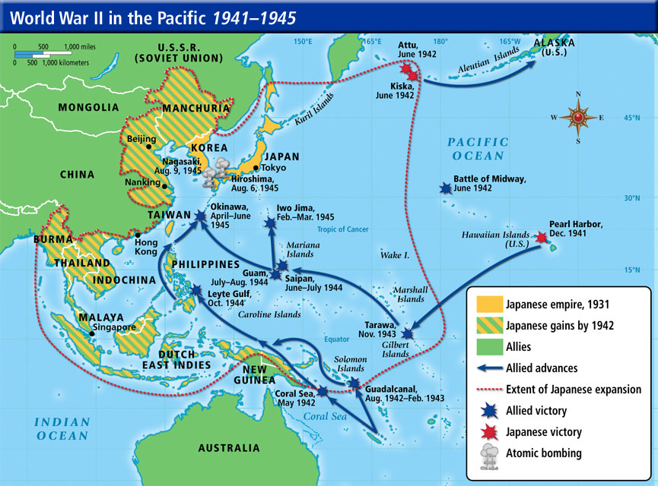
- During the latter stages of the war, the Army Air Force, operating east of the Mariana Islands and flying the B-29 Superfortress, had begun to firebomb the cities of Japan. These raids continued with the dropping of the atomic bombs on Hiroshima on August 6, 1945, and Nagasaki on August 9, 1945. Japan surrendered to the Allied on September 2, 1945.

