American History Name:
Date:
Source: America (2003); www.naacp.org Block:

Civil Rights in Mississippi, 1961-1963
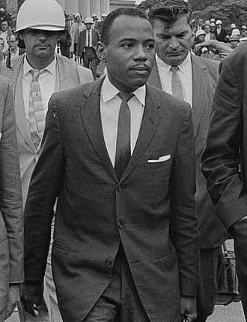
In 1961, James Meredith, an African American Air Force veteran, fought a personal battle for equal rights. Meredith was a student at Jackson State College, but he wanted to transfer to the all-white University of Mississippi, known as “Ole Miss.” After being rejected, Meredith got legal help for the NAACP. It filed a lawsuit claiming that Meredith’s application was turned down on racial grounds.
James Meredith
In the summer of 1962, the Supreme Court upheld Meredith’s claim. Mississippi Governor Ross Barnett, however, declared that Meredith could not enroll, regardless of what the Court said. Barnett personally blocked the way to the admissions office.
The issue became a standoff between the governor and the Justice Department. President Kennedy sent federal marshals to accompany Meredith to the campus. Crowds of angry white protestors, who had gathered around campus, destroyed their vehicles. As violence erupted on campus, tear gas covered the grounds. Two bystanders were killed and hundreds of people hurt. Finally, President Kennedy sent army troops to restore order, but federal marshals continued to escort Meredith to class. A month later, Meredith wrote an article for the Saturday Evening Post describing his experiences:
“It hasn’t been all bad. Many students have spoken to me very pleasantly. They have stopped banging doors and throwing bottles into my dormitory now. One fellow from my home town say down at my table in the cafeteria. ‘If you’re here to get an education, I’m for you,’ he said. ‘If you’re here to cause trouble, I’m against you.’ That seemed fair enough to me.”
James Meredith, 1962
Television cameras brought the scenes of violence to people across the country. Even those unsympathetic to the civil rights movement were appalled. As reporter Eric Sevareid observed, “A newspaper or television picture of a snarling police dog set upon a human being is recorded in the permanent photo-electric file of every human brain.”
Civil rights leaders continued to sponsor non-violent means of protest. Martin Luther King Jr. was arrested in April of 1963 where he wrote his famous Letter from Birmingham Jail, a document which preached the value of nonviolence as well as the justification for blacks to continue to challenge certain aspects of society.
Later that same year, in June, Mississippi was again at the center of the movement. Medgar Evers was a native of Decatur, Mississippi. In 1943, he was inducted into the U.S. Army and served valiantly at the Battle of Normandy. However, Evers soon found that his skin color restricted his own freedom at home when he and five friends were forced away at gunpoint from voting in a local election. Despite his resentment over such treatment, Evers enrolled at Alcorn State University, majoring in business administration. While in school, Evers stayed busy by competing on the school’s football and track teams, also competing on the debate team, performing in the school choir, and serving as the president of the junior class.
He married classmate Myrlie Beasly on December 24, 1951 and completed work on his degree the following year. Medgar Evers became involved in the Regional Council of Negro Leadership (RCNL), a civil rights and pro self-help organization. Involvement in the RCNL gave Evers crucial training in activism. He helped to organize the RCNL’s boycott of service stations that denied blacks use of their restrooms. The boycotters distributed bumper stickers with the slogan “Don’t Buy Gas Where You Can’t Use the Restroom.” Along with his brother, Charles Evers, he also attended the RCNL’s annual conference from 1952-1954, which drew crowds of ten thousand or more.
Evers applied to the then-segregated University of Mississippi Law School in February 1954. When his application was rejected, Evers became the focus of an NAACP campaign to desegregate the school, a case aided by the U.S. Supreme Court ruling in the case of Brown v. Board of Education that segregation was unconstitutional. In December of that year, Evers became the NAACP’s first field officer in Mississippi.
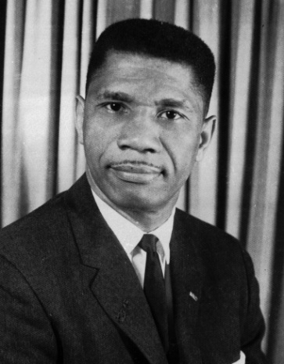
After moving to Jackson, Mississippi, he was involved in a boycott campaign against white merchants and was instrumental in eventually desegregating the University of Mississippi when that institution was finally forced to enroll James Meredith in 1962.
In the weeks leading up to his death, Evers found himself the target of a number of threats. His public investigations into the murder of Emmett Till and his vocal support of Clyde Kennard (another activist who attempted to desegregate higher education in Mississippi) left him vulnerable to attack. On May 28, 1963, a Molotov cocktail was thrown into the carport of his home, and five days before his death, he was nearly run down by a car after he emerged from the Jackson NAACP office. Civil rights demonstrations accelerated in Jackson during the first week of June 1963. A local television station granted Evers time for a short speech, his first in Mississippi, where he outlined the goals of the Jackson movement. Following the speech, threats on Evers’ life increased.
Medgar Evers
On June 12, 1963, Evers pulled into his driveway after returning from an integration meeting where he had conferred with NAACP lawyers. Emerging from his car and carrying NAACP t-shirts that stated, “Jim Crow Must Go,” Evers was struck in the back with a bullet that ricocheted into his home. He staggered 30 feet before collapsing, dying at the local hospital 50 minutes later. Evers was murdered just hours after President John F. Kennedy’s speech on national television in support of civil rights.
Mourned nationally, Evers was buried on June 19 in Arlington National Cemetery and received full military honors in front of a crowd of more than 3,000 people, the largest funeral at Arlington since John Foster Dulles. The past chairman of the American Veterans Committee, Mickey Levine, said at the services, “No soldier in this field has fought more courageously, more heroically than Medgar Evers.”
On June 23, Byron De La Beckwith, a fertilizer salesman and member of the White Citizens’ Council and Ku Klux Klan, was arrested for Evers’ murder. During the course of his first 1964 trial, De La Beckwith was visited by former Mississippi governor Ross Barnett and one time Army Major General Edwin A. Walker.
All-white juries twice that year deadlocked on De La Beckwith’s guilt, allowing him to escape justice. In response to the murder and miscarriage of justice, Bob Dylan wrote the song “Only a Pawn in Their Game” about Evers and his assassin.
In 1994, thirty years after the two previous trials had failed to reach a verdict, Beckwith was again brought to trial based on new evidence concerning statements he made to others. During the trial, the body of Evers was exhumed from his grave for autopsy, and found to be in a surprisingly excellent state of preservation as a result of embalming, Beckwith was convicted on February 5, 1994, after living as a free man for three decades after the murder. Beckwith appealed unsuccessfully, and died in prison in January 2001.
Evers’ wife, Myrlie, became a noted activist in her own right later in life, eventually serving as chairwoman of the NAACP and most recently delivering the invocation at the Presidential Inauguration of Barack Obama in 2013.

