American History Name:
Mr. Murray Date:
Sources: America (2003); Kenneth C. Davis, Don’t Know Much About History (2003)
The 1920s
The 1920s was a period of boom for the United States. More than just a time between two world wars, the 1920s literally set in motion much of modern American. Cars hit the roads. Business boomed. Radios crackled. Hemlines moved up. The nation moved to the new sound of jazz, while the tiny town of Hollywood gave the world motions pictures. Optimism and faith in business and technology characterized the U.S. in the 1920s. But the prosperity of the 1920s was fragile and would quickly give way to a period of severe economic distress known as the Great Depression.
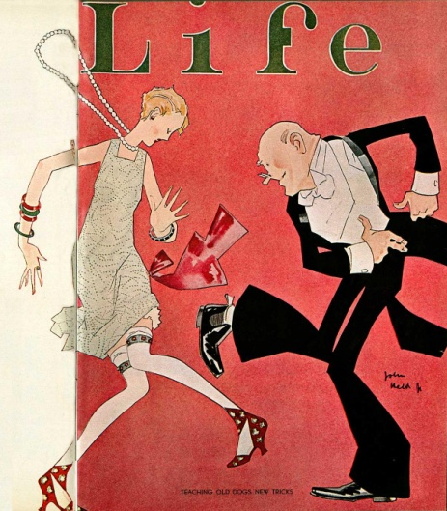
The Great War was over. Disillusioned and shocked by its frightful toll, Americans wanted to retreat to the sage shell of prewar isolationism. The country wanted to get back to business. That meant putting Republicans back in the White House. Starting in 1921, a Republican held the presidency for the next twelve years. First was Warren G. Harding, who campaigned on the promise of a “return to normalcy.” After he was elected in 1920, the highlights of his weak administration were the loud whispers of presidential philandering and the infamous Teapot Dome scandal of 1922. In the midst of that scandal, Harding died and was replaced by Calvin Coolidge, best remembered for his pronouncement that “the business of America is business.” Known as Silent Cal, he also said, “The man who builds a factory builds a temple. And the man who works there worships there.”
Under Coolidge, America seemed to prosper during the Roaring Twenties, a period in which the booming stock market was the centerpiece of a roaring economy. This was the exuberant era in which convention and old-fashioned morality were tossed aside—in spite of Prohibition—in favor of the freewheeling spirit of the Jazz Age, the days of wild new dances like the Charleston, of hip flasks and of women shucking Victorian undergarments and donning short skirts. It was the period that provided the inspiration for the fiction of F. Scott Fitzgerald, including the great representative character of the era, Jay Gatsby.
A new industry in a far off patch of California called Hollywood was producing a diversion that took America’s mind off its troubles, which seemed to be few in the twenties. By 1927, a Jewish singer in blackface named Al Jolson told the country, “You ain’t seen nothing yet,” in the first “talkie,” The Jazz Singer, and Hollywood was soon mounting multimillion-dollar productions to meet an insatiable demand for movies.
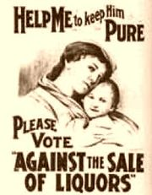
Two major Amendments were drafted and ratified just before the decade of the 1920s. Both Amendments meant drastic changes were ahead for American society and both Amendments are prime examples of the changing culture that was about to take American by storm in the 1920s. The first of the two, the Eighteenth (18th) Amendment was ratified, or approved, on January 29, 1919, in response to a decades-long fight led by the leaders of the temperance movement. The temperance movement was a social movement designed to rid the nation of its sins. One of those sins, alcohol, was seen as a cancer in American society. The consumption and abuse of liquor was seen as a major concern for American families, especially in a time when women had few rights and even fewer available options for help. Alcohol abuse, particularly among men, led to abuse physical, emotional, and sexual abuse within the home and often times ruined the family structure. The temperance movement, therefore, was driven by the need and desire to reclaim the American family and re-establish moral values in the home. The Eighteenth Amendment was written as follows:
Section 1: After one year from ratification of this article, the manufacture, sale, or transportation of intoxicating liquors within, the importation thereof into, or the exportation thereof from the United States and all territory subject to the jurisdiction thereof for beverage purposes is hereby prohibited.
Section 2: The Congress and the several States shall have concurrent power to enforce this article by appropriate legislation.
The goal of the Eighteenth Amendment was lofty and idealistic. But, as would be proven throughout the 1920s, to legislate morality is a difficult task in America, and Americans would find creative ways around the amendment.
A year later, on August 26, 1920, the Nineteenth Amendment was passed. With this groundbreaking amendment, women in the United States were given the right to vote. Similar to the 18th Amendment in that it was a process decades in the making, the women’s suffrage movement (the right to vote) had been debated even before the Civil War. Women made strides but could never fully achieve suffrage. All that changed during World War I. With men away fighting, it was women who stepped up and carried on the work at home. Women became members of the ambulance corps and took jobs in the medical field left open by men fighting. With women actively participating in society and fulfilling their patriotic duty, it became difficult to deny them the same rights as men. Gender lines were blurred during the war, and so to were feelings and sentiments about gender equality. Another major stumbling block for women’s suffrage was the liquor industry. Fearing that women having the right to vote would lead directly to the prohibition of alcohol, the liquor industry fought hard to keep women out of the political sphere. Once the 18th Amendment had been passed, it was only an amount of time before women would receive the right to vote. The 19th Amendment:
The right of citizens of the United States to vote shall not be denied or abridged by the United States or by any State on account of sex. Congress shall have power to enforce this article by appropriate legislation.
With the passage of these two Amendments, American society would be forced into a new age; an age where women were being liberated, old Victorian values would be tested, and outright violation of the law would be perpetrated often and by many.

