American History Name:
Date:
Sources: Smithsonian Magazine, “The Freedom Riders, Then and Now” by Marion Smith Holmes (2009); Block:

Freedom Riders
On Sunday, May 14, 1961—Mother’s Day—scores of angry white people blocked a Greyhound bus carrying black and white passengers through rural Alabama. The attackers pelted the vehicle with rocks and bricks, slashed tires, smashed windows with pipes and axes and lobbed a firebomb through a broken window. As smoke and flames filled the bus, the mob barricaded the door. “Burn them alive,” somebody cried out. “Fry the goddamn niggers.” An exploding fuel tank and warning shots from arriving state troopers forced the rabble back and allowed the riders to escape the inferno. Even then some were pummeled with baseball bats as they fled.
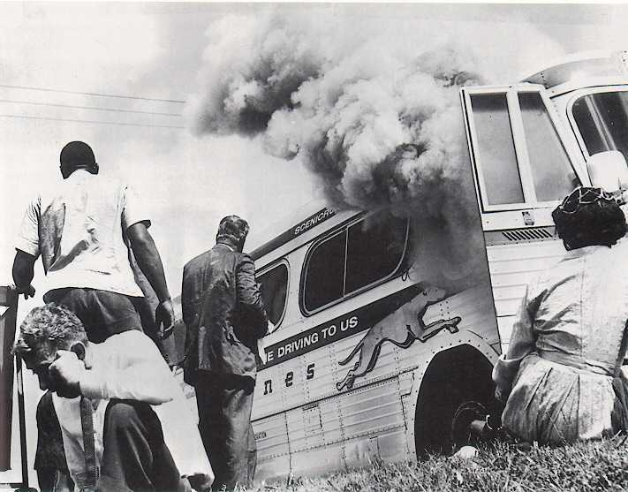
A few hours later, black and white passengers on a Trailways bus were beaten bloody after they entered whites-only waiting rooms and restaurants at bus terminals in Birmingham and Anniston, Alabama. The bus passengers assaulted that day were Freedom Riders, among the first of more than 400 volunteers who traveled throughout the South on regularly scheduled buses for seven months in 1961 to test a 1960 Supreme Court decision that declared segregated facilities for interstate passengers illegal.
After news stories and photographs of the burning bus and bloody attacks sped around the country, many more people came forward to risk their lives and challenge the racial status quo. Nearly 75 percent of them were between 18 and 30 years old. About half were black; a quarter, women. Their mug-shot expressions (kept in archival files held by the Mississippi State Sovereignty Commission, an agency created in 1956 to resist desegregation) hint at their resolve, defiance, pride, vulnerability, and fear. Most of the riders were college students; many, such as the Episcopal clergymen and contingents of Yale divinity students, had religious affiliations. Some were active in civil rights groups like the Congress of Racial Equality (CORE), which initiated the Freedom Rides and was founded in 1942 on Mahatma Gandhi’s principle of nonviolent protest. The goal of the rides, CORE director James Farmer said, was “to create a crisis so that the federal government would be compelled to enforce the law.”
The volunteers, from 40 states, received training in nonviolence tactics. Those who could not refrain from striking back when pushed, hit, spit on or doused with liquids while racial epithets rang in their ears were rejected.
As soon as he heard the call for riders, Robert Singleton remembers, he “was fired up and ready to go.” He and his wife, Helen, had both been active in the National Association for the Advancement of Colored People and they took 12 volunteers with them from California.
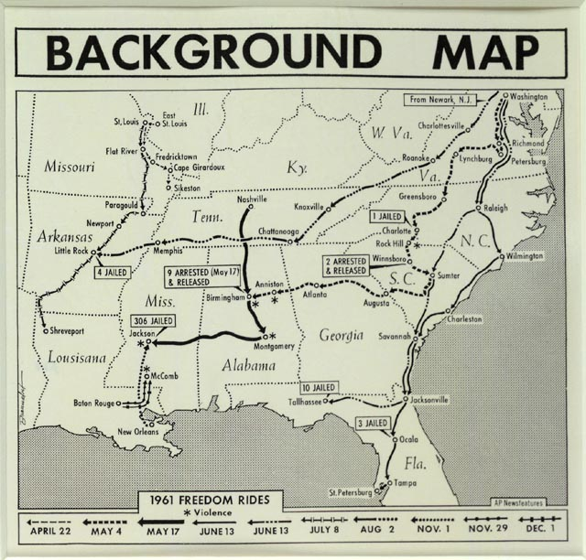
Peter Ackerberg, a lawyer who now lives in Minneapolis, said that while he’d always talked a “big radical game,” he had never acted on his convictions. John Lewis, then 21 and already a veteran of sit-ins to desegregate lunch counters in Nashville, was the first Freedom Rider to be assaulted. While trying to enter a whites-only waiting room in Rock Hill, South Carolina, two men set upon him, battering his face and kicking him in the ribs. Less than two weeks later, he joined a ride bound for Jackson. “We were determined not to let any act of violence keep us from our goal,” Lewis said. “We knew our lives could be threatened, but we had made up our minds not to turn back.”
As riders poured into the South, National Guardsmen were assigned to some buses to prevent violence. When activists arrived at the Jackson bus depot, police arrested blacks who refused to heed orders to stay out of white restrooms or vacate the white waiting room. And whites were arrested if they used “colored” facilities. Officials charged the riders with break of peace, rather than breaking segregation laws. Freedom Riders responded with a strategy they called “jail, no bail”—a deliberate effort to clog the penal facilities. Most of the 300 riders in Jackson would endure six weeks in sweltering jail or prison cells ride with mice, insects, soiled mattresses and open toilets.
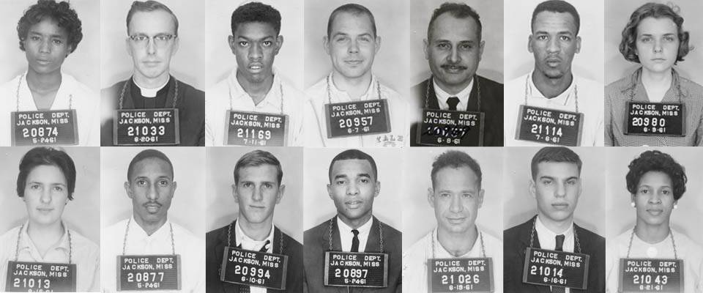
The prisoners often went through the dehumanizing process of being stripped naked. When being transferred from one facility to another, unexplained stops on remote dirt roads or the sight of curious onlookers peering into the transport trucks heightened fears. To keep their spirits up, the prisoners sang freedom songs.
The Freedom Riders have few regrets today. Many of them became teachers or professors, ministers, lawyers, Peace Corps workers, journalists, and politicians. Some still practice civil disobedience. Though the Freedom Rides dramatically demonstrated that some Southern states were ignoring the U.S. Supreme Court’s mandate to desegregate bus terminals, it would take a petition from U.S. Attorney General Robert Kennedy to spur the Interstate Commerce Commission (ICC) to issue tough new regulations, backed by fines of up to $500, that would eventually end segregated bus facilities. Even after the order went into effect, on November 1, 1961, hard-core segregation persisted; still, the “white” and “colored” signs in bus stations across the South began to come down.

