American History Name:
Mr. Murray Date:
Sources: adapted from America (2003); University of Texas Diversity in Higher Education Block:

Introduction to the Civil Rights Movement: Phase I

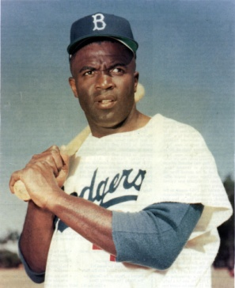
In August 1945, Branch Rickey, the general manager of the Brooklyn Dodgers, called a young man named Jackie Robinson into his office. Rickey told Robinson of his plan to challenge the rule in Major League Baseball that required African Americans to play in a separate Negro League. Rickey wanted Robinson, a promising athlete in college and a World War II veteran, to be the first player to break the color barrier.
To test how Robinson would respond to the pressure he was likely to face, Rickey acted the part of those who might try to discourage him. He roared insults at Robinson and threated him with violence. “Mr. Rickey,” Robinson finally said, “do you want a ballplayer who’s afraid to fight back?” Rickey answered, “I want a player with guts enough not to fight back.”
In 1947, Robinson joined the Brooklyn Dodgers, becoming the first African American to play in the Major Leagues. Despite many instances of prejudice, Robinson behaved with dignity and had a sparkling first season. He was named Rookie of the Year in 1947. In 1949, he was voted the league’s most valuable player. Just as important, Robinson fostered pride in African Americans around the country and paved the way for other African Americans to follow him into professional sports.
Throughout the early twentieth century, African Americans made strides in many areas of society. The Great Migration between 1910 and 1940 saw the emergence of large black populations in the north and west. Under Roosevelt’s New Deal, many African Americans went to work for the federal government. During World War II, blacks fought for a “double victory,” meaning a victory for America in war, and a victory for the equal status of African Americans. In 1948, President Truman passed Executive Order 9981 which desegregated the armed forces. The creation of the NAACP fought diligently to challenge segregation laws and improve the status of African Americans throughout the U.S.
It is difficult to pinpoint when exactly the Civil Rights Movement began and ended. In many ways, the Civil Rights Movement is still in effect, fighting for equality for women, American Indians, Hispanic Americans, homosexuals, etc. But the majority of the movement, and the period with the most effective change occurred during the 1950s and 1960s, when America was facing upheaval on multiple fronts. While some clung to traditional ways and values, others wholeheartedly sought to overhaul the system and make lasting, impactful change.
There are three major phases of the Civil Rights Movement between 1950 and 1968. The first phase involves taking issues of concern to the federal courts. The judicial system of the U.S. is designed to seek justice for its citizens. Many believed that if they could change the law, they could change society. But that isn’t always the case, and people are not always willing to change, even when told they have to by law. The second phase entails utilizing non-violent forms of protests. These non-violent protests were designed to peacefully demonstrate peoples’ frustrations with society and how they were being treated. Non-violent protests were used in a variety of ways. From sit-ins, to boycotts, to marches, to speeches and rallies, minorities across the country were able to make their voices heard. And, with the widespread use of television, people across the nation were able to see these demonstrations. The television brought the Civil Rights Movement into everyone’s home. The third and final phase marks a drastic shift in ideology and methodology. After a period of utilizing non-violence as a means for public policy change, civil rights leaders and reformers felt they needed to change their approach. They were unhappy that changes were not occurring fast enough and needed to force the government’s hand. The third phase is littered with violence and outright opposition.
It is important to recognize that the Civil Rights Movement is not simply a “white/black” issue. While we tend to associate the Civil Rights Movement with African Americans, many others were affected by it. Women, Hispanics, Asian Americans, American Indians and the like all participated in and influenced the Civil Rights Movement.

Phase I: Taking it to the Federal Courts
The 1896 Supreme Court ruling in the case of Plessy v. Ferguson set a tone in America. It determined that “separate but equal” was constitutional in regards to segregating the races. Americans would spend decades attempting to overturn this ruling. Few victories were made along the way. In the 1930s, Lloyd Gaines, an African American male, applied for entrance into the University of Missouri law school. He was denied admission due to his race. Gaines sued on the basis that this was a violation of Plessy v. Ferguson; while Missouri offered to pay for his tuition at an out-of-state university, Gaines argued that because Missouri did not have a black university with a law school they could not deny him admission. In 1930, the Supreme Court agreed with Gaines. While the Gaines v. Canada case can be considered a victory for African Americans, it does nothing to overturn Plessy v. Ferguson.
In 1946, Heman Marion Sweatt, an African American male, applied for entrance into the University of Texas Law School, a nationally ranked school. He was denied admission based on his race. When he sued, the Texas courts delayed hearing the case until a black school could be opened in Houston, thus meeting the “separate but equal” requirement. Sweatt appealed all the way to the Supreme Court, who ruled in favor of Sweatt in 1950. The Sweatt v. Painter decision was based on the fact that even though there was a separate facility for blacks, the quality of education was not equal. In 1950, Sweatt entered the University of Texas school of law.
In 1951, Oliver Brown sued the Topeka, Kansas, Board of Education to allow his 8-year old daughter Linda to attend a nearby school for whites only. Every day, Linda walked past the school on her way to the bus that took her to a distant school for African Americans. After appeals, the case reached the Supreme Court. There, Thurgood Marshall, a former lawyer for the NAACP, argued on behalf of Brown and against segregation in America’s schools.
On May 17, 1954, in Brown v. Board of Education of Topeka, Kansas, the Supreme Court issued its historic ruling. In a unanimous decision, the Court declared that the “separate but equal” doctrine was unconstitutional and could not be applied to public education. A year later, the Court ruled that local school boards should move to desegregate “with all deliberate speed.”
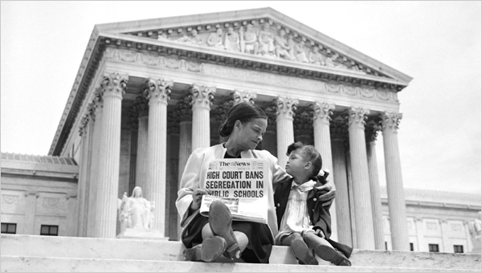
The public’s reaction to the Supreme Court’s ruling was mixed. African Americans rejoiced. Many white Americans, even if they did not agree, accepted the decision and hoped that desegregation could take place peacefully. President Eisenhower, who privately disagreed with the Brown ruling, said only that “the Supreme Court has spoken and I am sworn to uphold the constitutional processes in this country, and I am trying. I will obey.” Not everyone, however, was willing to obey.
The ruling in Brown v Board of Education caused many southern whites especially in the Deep South, to react with fear and angry resistance. In Georgia, Governor Herman Talmadge made it clear that his state would “not tolerate the mixing of the races in the public schools or any other tax-supported institutions.” The Ku Klux Klan also became more active, threatening those who advocated acceptance of the Brown decision. The congressional representatives of the states in the Deep South joined together in March 1956 to protest the Supreme Court’s order to desegregate public schools. More than 90 members of Congress expressed their opposition to the Court’s ruling in what was known as the “Southern Manifesto.” The congressmen asserted that the Supreme Court had overstepped its bounds and had “no legal basis for such action.” The decision, they claimed, violated states’ rights and was an example of “judicial usurpation.” Many believed that desegregation would lead to violence and chaos in several southern states. As a result, they refused to comply with the court’s ruling, demonstrating their desire and willingness to take a stand against integration, even if it was legally mandated.

