World History Name:
Mr. Murray Date:
Salah al-Din (Saladin) Block:

The Middle East did not experience the Dark Ages as Europe did. Instead, between 750 and 1300, the Islamic Empire flourished in what is known as, “The Golden Age of Islam.” At its height the Muslim Empire ruled lands all across northern Africa and its influence stretched from India in the east to Spain in the west. Islamic beliefs were expressed in government, the arts, social customs, and business. The Islamic religion and the Arabic language united people from different backgrounds over a huge area.

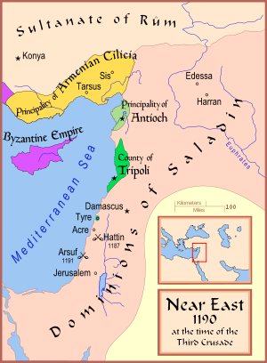
Islamic culture at the time of the Crusades was the polar opposite of Europe. The Muslim world was full of great accomplishments including paved streets, street lights at night, water pipes, running water, baths, fountains, irrigation, and crop rotation. Agriculture included oranges, melons, pepper, ginger, cloves, rice, sesame, dates, lemons and sugar. None of these had ever been seen in Europe. Arabian horses and advanced steel making techniques contributed to excellence of the military. It was, however, in the area of learning where the Islamic Empire really excelled beyond Europe. Islam had many new advances and more importantly the preservation of the old learning of the Greeks and Romans. Mathematicians acquired the idea of “zero” from India, invented algebra (“al-jabr”), and worked out new ideas in trigonometry and geometry. Scientists discovered basic chemical processes and formulas and made new compounds. “Alcohol” and “alkali” were originally Arabic words.

Astronomers in Spain and Baghdad calculated the movements of stars and planets and made accurate star maps. Islamic medicine was the most advanced in the world. Al-Razi headed the hospital in Baghdad in the 9th century and wrote a medical encyclopedia in which he scientifically discussed measles, kidney stones, poisons, skin diseases, and general ways of staying healthy. Muslim culture also enjoyed luxuries like perfume, powder, silk, velvet, and using dye on clothing.

The most remarkable military and political ruler of Islam at this time was Ysusf Salah ad-Din, known to the West simply as “Saladin.” He was born with the name “Yusuf ibn Ayyub” (Joseph son of Job) in Tikrit, Iraq near the Tigris River in 1138. “Saladin” is a title that comes from “Salah-Al-Din” which means “Protector of the Faith.” Saladin was born in what is modern day Iraq.

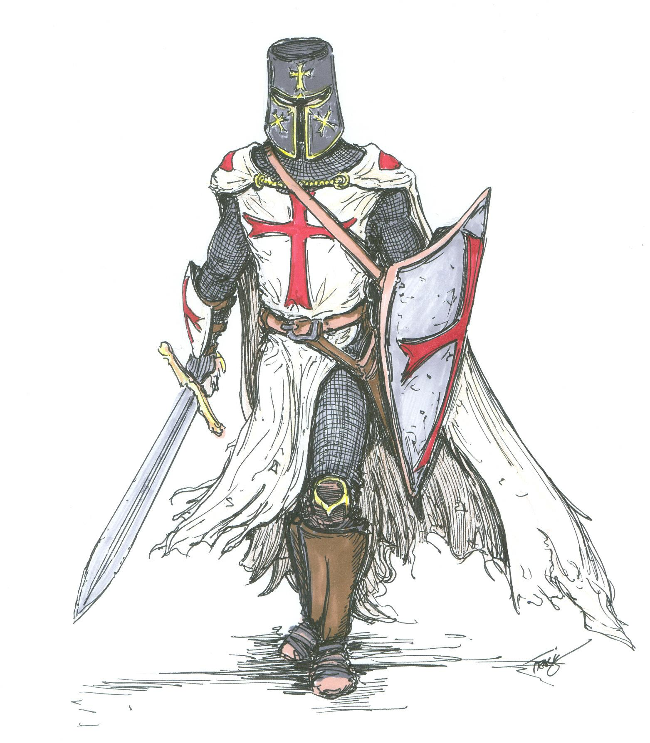
Saladin’s army fought the European crusaders during the Third Crusade (1187-1192). European knights were supposed to fight according to the Knight’s Code of Chivalry. This was not the case in the Middle East where they were told by their priests, “It is God’s will to murder the infidel.” The crusaders raped Muslim women and children; they slaughtered Muslim prisoners of war; crusaders tortured Muslim captives for the sheer sport of it; they burned cities to the ground; European knights poisoned Muslim wells with dead animals and human waste; they plundered and pillaged Muslim homes; and they raided unarmed Muslim trade caravans. The cruelest of the crusaders was a French prince, Prince Raynald de Châtillion. He ruled the European Christian principality of Antioch (see the map). Raynald’s knights were called the Knights Templar. They were infamous for their cruelty and hatred of the Muslims. Raynald’s Knights Templar attacked innocent Muslim caravans carrying goods, while his ships raided like the Mediterranean coast as pirates. When Raynald’s Knights Templar captured Muslim prisoners he had them stripped naked, castrated, their eyes scooped out with spoons, their bodies covered with honey, and then left out in the sun to roast alive. Raynald viewed the Muslims of the Middle East as the infidel, worthy only of dying by the sword.

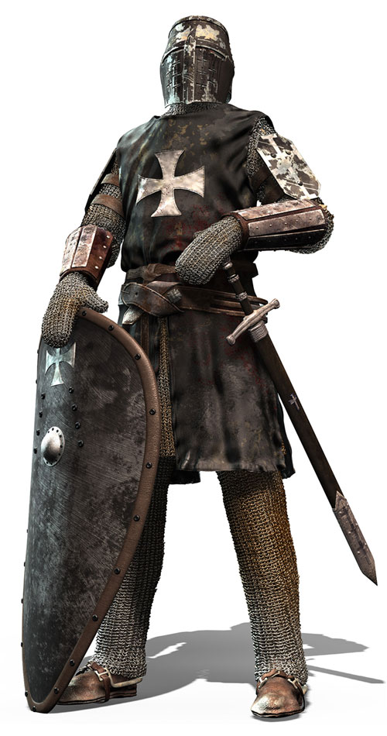
Another of Saladin’s main enemies was a French duke named Guy de Lusignan. Guy (Gēē) wanted to become the King of Jerusalem. At this time Jerusalem, known as “the Kingdom of Heaven,” was ruled by King Baldwin. King Baldwin was dying of leprosy. Leprosy is a skin disease where the skin literally rots off of the body. King Baldwin’s face was such a mess from the ravages of the disease that he had to wear a solid silver mask so he wouldn’t sicken the people around him. King Baldwin wanted to keep the peace in the Holy Land. He had deep respect for Saladin and for Islam. King Baldwin believed Muslims, Christians and Jews could live side-by-side in peace in Jerusalem, something they had been doing for the past ninety years. King Baldwin’s knights were called Knights Hospitalers. King Baldwin had signed a peace treaty with Saladin.
French Knight Templar of Raynald de Châtillion

The Knights Hospitalers were an enormously disciplined fighting force who followed the Knights Code of Chivalry. King Baldwin favored peace with Saladin. He ordered his Knights Hospitalers to respect Muslim culture and to honor the peace treaty. The problem was King Baldwin was dying of leprosy. Guy was bidding his time and making plans to provoke Saladin into war.
French Knights Hospitaliers of King Baldwin
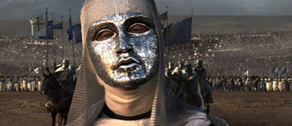
Without the knowledge of King Baldwin, Guy and prince Raynald wanted to start a war with Saladin so the Christian crusaders could destroy Muslim civilization in the Holy Land once and for all. To start the war with Saladin, Raynald and his Knights Templar ambushed and massacred Muslim trade caravans in the desert. For Saladin, this was the final straw. An imam is a Muslim religious leader and only an imam can declare a lesser jihad. Following the destruction of Muslim trade caravans by Raynald’s Knights Templar, Saladin’s imam declared jihad against the “infidel Christian crusaders.”
King Baldwin, King of Jerusalem

King Baldwin died of his awful disease in 1186. By 1187 the warlike, anti-Muslim Guy was now King of Jerusalem. 1187 is also important because the Battle of Hattin was fought on 4 July 1187. In the 12th century, Saladin was considered not only to be the greatest military mind in the Middle East, but the greatest military mind in the entire world. Saladin represented the best of Muslim culture. He was a brilliant mathematician; he composed and wrote beautiful poetry, glorifying the prophet Mohammad; he spoke five languages fluently; he was an orthodox Muslim religiously praying to Allah five times a day; he was just; he was kind; he was cultured; and he was civilized. Yet, perhaps Saladin’s greatest gift was he that he was the most brilliant military thinker of his day.
At the beginning of July at the height of the summer heat, where daily temperatures approached 100 degrees, King Guy and Prince Raynald lead a crusader army of 20,000 heavily armored men out of Jerusalem and into the desert. Their goal was to start a war with Saladin. Knowing the desert like the back of his hand, Saladin’s forces watched the crusader forces from a distance. On the horizon the crusader army could see Saladin’s scouts, but Saladin’s army was under strict orders: do not strike; draw the crusaders into the desert away from their sources of water.
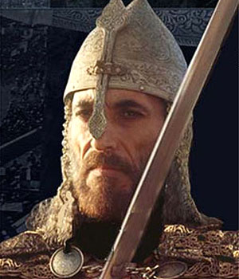
Staggering under the weight of their armor, parched from the heat, dying of thirst and lost in the desert wilderness, the army of King Guy and Prince Raynald were ripe for disaster. On 4 July 1187 Saladin struck at Hattin (map, page 1). The crusaders called Saladin’s army Saracens. “Saracen” was the European term for “easterner.” The Saracens were skilled horsemen and deadly horse-archers. Riding at a full gallop, Saracen bowmen could hit a moving target from fifty yards. Trained as superb riders and lethal bowmen, Saladin’s Saracens could unleash ten arrows a minute at a full gallop. Once the enemy was crippled from the unrelenting rain of arrows, the Saracens would go in for the kill with sword and lance. The iron weapons of Saladin’s army were superior to those of the European knights since Islamic steel was of superior quality than its European counterpart.
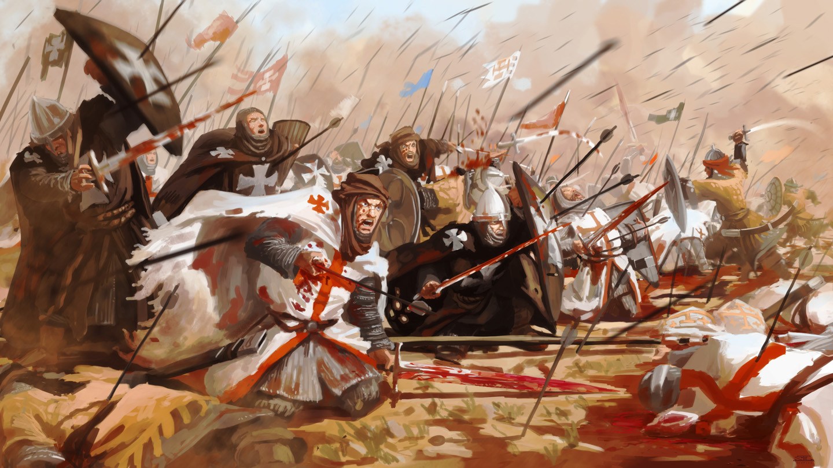
Adding to the crusaders misery, Saladin had fires set in the valley of Hattin. Once the crusaders were blinded by the smoke and gasping for air, Saladin’s Saracens attacked the crusaders from every side at once. The crusaders were cut to pieces. In less than four hours the field of battle at Hattin was carpeted with the bloated bodies of dead knights. Saladin’s 30,000 man army had annihilated an entire crusader army in less than half a day.
Ysusf Salah ad-Din, (Saladin)
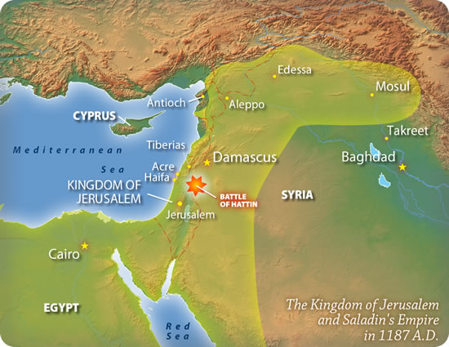
Both King Guy and Prince Raynald were captured alive. When the two were brought to Saladin’s tent, Saladin offered King Guy a cup of cold water with pieces of ice, a traditional offering of Muslim hospitality. When Prince Raynald grabbed the cup and gulped down the water intended for Guy, Saladin cut off Raynald’s head with a single swipe from his scimitar. King Guy fell to his knees besides the still twitching corpse. Saladin told him to rise and said, "A king does not kill a king.” Saladin spared King Guy’s life. He was kept alive in a prison in Damascus. Only twice in his military campaigns against the crusaders did Saladin order the execution of crusader prisoners. Hattin was one of those times. One by one the crusader prisoners were beheaded creating a mountain of heads over eighteen feet tall. With King Guy’s 20,000 man army annihilated, Jerusalem was now virtually defenseless. Saladin shifted his army south to reclaim Jerusalem. His Saracens would take back Islam’s second holiest city and free it from the infidel.
Battle of Hattin, 4 July 1187

