American History Name:
Date:
Source: America (2003) Block:
Expansion of the Cold War
McCarthyism
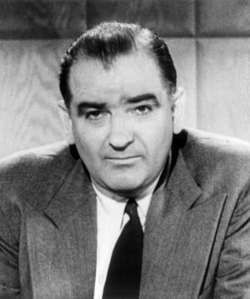
Communist aggression in Korea was already heightening Americans’ fear of communism when Wisconsin Senator Joseph McCarthy held up a piece of paper and declared, “I have here in my hand a list of 205 people who were known to the secretary of state as being members of the Communist Party and who, nevertheless, are still working and shaping policy at the State Department.” In the Cold War atmosphere of 1950, McCarthy’s charges quickly gained so much support that only the most courageous spoke out against him. One such person was Edward R. Murrow, who concluded his TV show on McCarthy by saying that “this is no time for men who oppose Senator McCarthy to keep silent.”
In 1950, it seemed to many Americans that the events in Asia supported McCarthy’s sensational charges. However, the famous list of the 205 known State Department Communists turned out to be the names of people who were still employed by the government, even though they had been accused of disloyalty under Truman’s loyalty program. When pressed for details, the senator reduced the number for 205 to 57. Nevertheless, McCarthy’s accusations sparked an anti-Communist hysteria and national search for subversives that caused suspicion and fear across the nation.
Joseph McCarthy’s first term in the Senate had been undistinguished and he needed an issue to arouse public support. He found that issue in the menace of communism. Piling baseless accusations on top of the unprovable charges, McCarthy took his crusade to the floor of the Senate and engaged in the smear tactics that came to be called McCarthyism. Not only was McCarthy reelected, but he became chairman of an investigations subcommittee. Merely being accused by McCarthy caused people to lose their jobs and reputations.
McCarthy soon took on larger targets. He attacked former Secretary of State George Marshall, a national hero and a man of unquestioned integrity. McCarthy claimed that Marshall was involved in “a conspiracy so immense and an infamy so black as to dwarf any previous venture in the history of man,” because of his inability to stop the Communist triumph in China.
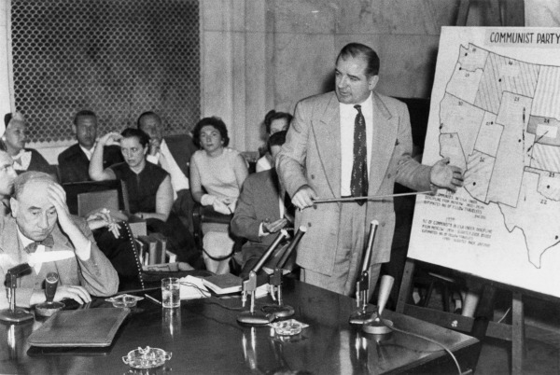
Even other senators came to fear McCarthy. They worried that their opposition to his tactics would brand them as Communist sympathizers. But there were a few exceptions. As early as June 1950, Republican Senator Margaret Chase Smith of Maine presented a Declaration of Conscience to the Senate. She denounced McCarthy for having “debased” the Senate “to the level of a forum of hate and character assassination sheltered by the shield of congressional immunity…”
In early 1954, when one of his assistants was drafted, McCarthy charged that even the army was full of Communists. Army officials, in turn, charged McCarthy with seeing special treatment for his aide. As charges and countercharges flew back and forth, the senator’s subcommittee voted to investigate the claims.
The Army-McCarthy hearings began in late April 1954. Democrats asked that the hearings be televised, hoping that the public would see McCarthy for what he was. Ever eager for publicity, the senator agreed. For weeks, Americans were riveted to their television sets. Most were horrified by McCarthy’s bullying tactics and baseless allegations.
By the time the hearings ended in mid-June, the senator had lost even his strongest supporters. The Senate formally condemned him for his reckless actions. Unrepentant, McCarthy charged his accusers with being tools of the Communists, but he no longer had credibility. Although McCarthy remained in the Senate, his power was gone. Eventually this second red scare, much like the one that followed World War I subsided. But the nation was damaged by the era’s suppression of free speech and open, honest debate.
The Arms Race
Throughout the 1950s, the United States and the Soviet Union waged an increasingly intense struggle for world leadership. Nowhere was this competition more dangerous than in the arms race, the struggle to gain weapons superiority.
In August 1953, less than a year after the United States exploded its first thermonuclear device, the Soviet Union successfully tested its own hydrogen bomb. As part of the policy of deterrence begun by President Truman, Eisenhower stepped up American weapons development. Deterrence is the policy of making the military power of the U.S. and its allies so strong that no enemy would dare attack for fear of retaliation. Between 1954 and 1958, the U.S. conducted 19 hydrogen bomb tests in the Pacific. One of these explosions, in March 1954, was over 750 times more powerful than the atomic bomb that had been dropped on Nagasaki. Japanese fisherman some 90 miles from the blast suffered severe radiation burns. The test was a chilling warning that nuclear war could threaten the entire world with radioactive contamination.
American policy makers used the fear of nuclear war to achieve their Cold War objectives. In 1956, Secretary of State John Dulles made it clear that the United States was prepared to risk war to protect its national interests. Brinkmanship is a term used by Secretary of State John Dulles to describe a policy of risking war in order to protect national interests. Despite its dangers, the Eisenhower administration relied heavily on this policy.
To carry hydrogen bombs to their targets, American military planners relied mainly on airplanes. Unable to match this strength, the Soviets focused on long-range rockets known as intercontinental ballistic missiles, or ICBMs. Americans also worked to developed ICBMs. However, in part because of its dependence on conventional air power, the United States lagged behind the Soviet Union in missile development.
The size of this technology gap became apparent in 1957, when the Soviets used on of their rockets to launch Sputnik, the first artificial satellite to orbit Earth. The realization that the rocket used to launch Sputnik could carry a hydrogen bomb to American shores added to American shock and fear.
In May 1960, the Soviet military against demonstrated its arms capabilities by using a guided missile to shoot down an American U-2 spy plane over Soviet territory. Because these spy planes flew more than 15 miles high, American officials had assumed that they were invulnerable to attack. The U-2 incident shattered this confidence, and made Americans willing to expend considerable resources to catch up to—and surpass—the Soviet Union.
One legacy of the Cold War was the creation of what Eisenhower called a “permanent armaments industry of vast proportions.” As he left office, he warned that the existence of this military-industrial complex, employing millions of Americans and having a financial state in war-making could become a threat to peace.

