World History Name:
Mr. Murray Date:
Barbarian Migrations and Invasions Block:

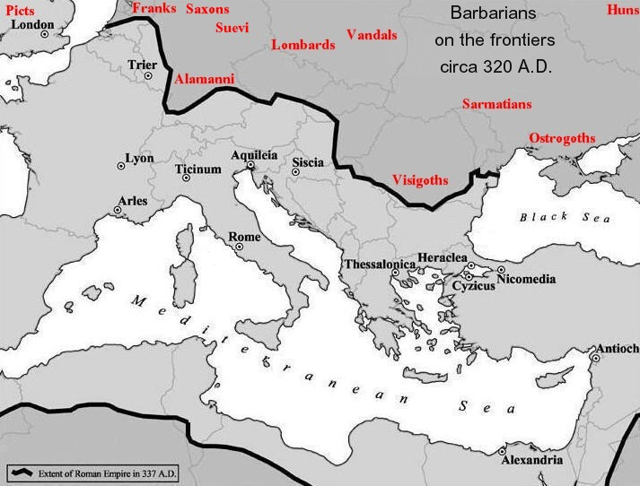
At its height, the Roman Empire stretched from the island now known as England in the West to the Persian Gulf in the Middle East to the East; and from the Rhine and Danube Rivers in the North to the Northern coast of Africa in the South. The Roman Empire was the largest Empire in the known world with one of the most diverse populations in the world. But extending from the northern border of the Roman Empire were a host of “barbarian” clans who lived a backward, brutish life; a far cry from Rome, the most advanced civilization ever seen. The word “barbarian” comes from the Greek “barbaroi,” meaning one who lives outside the benefits of a civilization. As the Roman Empire continued to expand from the 1st century CE, tensions grew between those within the empire and those without.
Relations between Rome and the barbarian tribes were not always hostile. The Roman legions were traditionally filled with citizens, and then later subjects, of the Roman Empire. Over the course of time, however, the Roman legions began to interact with barbarian tribes to the north. Deals were struck, and soon, for the promise of staying out of their land, the barbarian tribes agreed to fight for the Roman army when called upon. But over the course of time, the legions lost their appeal to the average Roman citizen and soon were filled with barbarians. In other words, the empire was being defended by people with no stake in the success of the empire. This is why the influence of barbarians is considered to be one of the main causes for the fall of Rome.
As other issues began to plague the empire, the relationship between the empire and the barbarian tribes also deteriorated causing the creation of an exceedingly dangerous environment. But who were these people? And how did they rise to such significance?
The barbarians of Europe lived in tribal groupings. The Franks in modern day France, the Vandals in Hungary, the Goths from Russia dominated the territory we would call Northern Europe, along with other groups like the Burgundians, the Lombards, Saxons, and Vandals, among others. The members of these tribes were farmers and herdsmen by necessity and warriors by instinct. The order and consistency of Rome was absent from the free territory of northern Europe. Thus, the tribes became increasingly warlike as a matter of survival; protecting their clan from other clans became an absolute necessity.
The basic unit was the clan, which consisted of a number of families whose warriors periodically gathered to approve the decisions of an elected leader by thwacking their spears against their shields. Gradually, larger bands were formed through alliances cemented by marriage, the exchange of gifts, or simple convenience. Chiefs emerged, who sometimes were even called kings, and surrounded themselves with warriors who had sworn an oath of loyalty in return for a share of loot. But understand, the barbarian warriors were nothing like the disciplined military of Rome; the barbarians lacked sophisticated weaponry and armor, fought with more of a mob-like mentality, and lacked the organization and refinement of the Roman legions. It is perhaps this reason that Rome was able to keep the barbarians at bay for over 300 years.
Interestingly enough, the connection between the legions and the barbarian tribes was solidified by the spread of Christianity. Christians, who had initially been persecuted within the Roman Empire, who was dominated by pagans, successfully and speedily spread their religion through the Empire from the 1st to 3rd centuries CE. The Emperor Constantine is often the one associated with the acceptance of the religion into the Empire. In 312 CE, as he was preparing for a crucial battle, Constantine saw a cross illuminated in the sky. That night, he had a dream that his men entered battle with the sign of the Cross emblazoned on their battle shields. Constantine then ordered his men to fight under the Christian sign. They won.
From this point on, Constantine expected the full tolerance of Christians living within the empire. In 337 CE, while on his deathbed, Constantine was baptized into the Christian faith, and from that point on, the empire itself would be Christian as well. These beliefs eventually made their way to the barbarian tribes who were also converted by their Roman counterparts. But this relationship between barbarism and Christianity seems ironic. Christianity is based in peace, and acceptance, and tolerance of others. Warring clans in the north were based in none of these things. Perhaps it is a combination of these ever-changing constants surrounding the empire that helped spell its demise.
In 285, some 30 years before Constantine’s rule, the Roman Empire was ruled by a man named Diocletian. Recognizing the problems of the empire (namely, the threat from barbarians, the dangers of Christianity, and the sheer size of the empire itself), Diocletian decided to divide the empire to a Western part (known as the “Roman Empire”), and an Eastern part (known as the “Byzantine Empire”). Each “empire” would thus be ruled by a Caesar (or emperor), and a vice-emperor, thus creating a 4-person rule, or tetrarchy. Diocletian ruled in the eastern empire, with the capital in Nicomedia (later Byzantium, then Constantinople, and finally its name today, Istanbul) and his appointee, Maximian, ruled in the West, with the capital in Rome. The initial idea of division made sense; each emperor could control his own portion of the empire, and, with the vice-emperors already in place, the question of succession, or who would take over next, would never be an issue. This would ultimately prove to be untrue, and the division of the empire can be seen as yet another problem facing Rome. 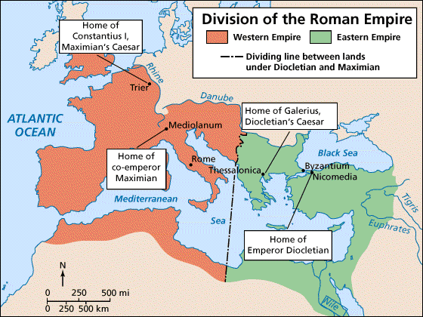
As the 5th century CE (400s) entered its second half, the Roman Empire was barely hanging on. Barbarian tribes had successfully gained territory from the Romans in France, Spain, and North Africa. The Western Empire, or the Roman Empire, consisted of only Italy and two other provinces by 455 CE. Finally, in 476 CE, a Gothic general named Odoacer overthrew the Roman emperor, Romulus Augustulus, signaling the end of the Roman Empire. With a barbarian in charge, all future progress would be forever halted. Rome was over. Progress was over. For the West, darkness would fall and time would stand still.